**A**

**Summer Internship Report On**

**DigiCSR**

(CE346 – Summer Internship - I)

**Prepared by** Darsh Aswani (21CE006) Krunal Jodhani (21CE045) Abhi Rupareliya (21CE117) Purv Sinojiya (21CE135)

# Under the Supervision of

Prof. Trusha R. Patel & Prof. Aayuhsi P. Chaudhary

# Submitted to

Charotar University of Science & Technology (CHARUSAT) for the Partial Fulfillment of the Requirements for the

Degree of Bachelor of Technology (B.Tech.)

for Semester 5

## Submitted at



**Accredited with Grade A+ by NAAC Accredited with Grade A by KCG**



**U & P U. PATEL DEPARTMENT OF COMPUTER ENGINEERING**

**Chandubhai S. Patel Institute of Technology (CSPIT) Faculty of Technology & Engineering (FTE), CHARUSAT At: Changa, Dist: Anand, Pin: 388421.**

**July 2023**

# Declaration by the candidates

We here by declare that the project report entitled “DigiCSR” submitted by us to, Chandubhai S. Patel Institute of Technology, Changa in partial fulfilment of the requirement for the award of the degree of B.Tech. in Computer Engineering, from U. And P U. Patel Department of Computer Engineering (CSPIT) is a record of bonafide CE346 – Summer Internship - I carried out by us under the guidance of Prof. Trusha R. Patel and Prof. Aayushi Chaudhari We further declare that the work carried out and documented in this project report has not been submitted anywhere else either in part or in full and it is the original work, for the award of any other degree or diploma in this institute or any other institute or university.

Darsh Aswani (21CE006) Krunal Jodhani (21CE045)

Abhi Rupareliya (21CE117) Purv Sinojiya (21CE135)

Prof. Trusha R. Patel, Assistant Professor

U & P U. Patel Dept. of Computer Engineering CSPIT, FTE, CHARUSAT, Changa, Gujarat

Prof. Aayushi Chaudhari Assistant Professor

U & P U. Patel Dept. of Computer Engineering CSPIT, FTE, CHARUSAT, Changa, Gujarat

**CERTIFICATE**

This is to certify that the report entitled “**DigiCSR**” is a bonafied work carried out by **Darsh Aswani (21CE006)** under the guidance and supervision of **Prof. Aayushi Chaudhari** for the subject **Summer Internship – I (CE346)** of 5th Semester of Bachelor of Technology in **Computer Engineering** at Chandubhai S. Patel Institute of Technology (CSPIT), Faculty of Technology & Engineering (FTE) – CHARUSAT, Gujarat.

To the best of my knowledge and belief, this work embodies the work of candidate himself, has duly been completed, and fulfills the requirement of the ordinance relating to the B.Tech. Degree of the University and is up to the standard in respect of content, presentation and language for being referred by the examiner(s).

Under the supervision of,

Prof. Aayushi Chaudhari Assistant Professor

U & P U. Patel Dept. of Computer Engineering CSPIT, FTE, CHARUSAT, Changa, Gujarat

Mr. Neel Shah Product Manager

Web Development Department Internauts Infotech

GIC ,Block 3 , L.D Eng. Boys Hostel, opp. Old Regional Passport office, Navrangpura, Ahmedabad, GJ 380009 IN





Dr. Nikita Bhatt

Head - U & P U. Patel Department of Computer Engineering, CSPIT, FTE, CHARUSAT, Changa, Gujarat.

**Chandubhai S. Patel Institute of Technology (CSPIT) Faculty of Technology & Engineering (FTE), CHARUSAT** At: Changa, Ta. Petlad, Dist. Anand, Pin: 388421. Gujarat.

**CERTIFICATE**

This is to certify that the report entitled “**DigiCSR**” is a bonafied work carried out by **Krunal Jodhani (21CE045)** under the guidance and supervision of **Prof. Trusha R Patel** for the subject **Summer Internship – I (CE346)** of 5th Semester of Bachelor of Technology in **Computer Engineering** at Chandubhai S. Patel Institute of Technology (CSPIT), Faculty of Technology & Engineering (FTE) – CHARUSAT, Gujarat.

To the best of my knowledge and belief, this work embodies the work of candidate himself, has duly been completed, and fulfills the requirement of the ordinance relating to the B.Tech. Degree of the University and is up to the standard in respect of content, presentation and language for being referred by the examiner(s).

Under the supervision of,

Prof. Trusha R Patel Assistant Professor

U & P U. Patel Dept. of Computer Engineering CSPIT, FTE, CHARUSAT, Changa, Gujarat

Mr. Neel Shah Product Manager

Web Development Department Internauts Infotech

GIC ,Block 3 , L.D Eng. Boys Hostel, opp. Old Regional Passport office, Navrangpura, Ahmedabad, GJ 380009 IN





Dr. Nikita Bhatt

Head - U & P U. Patel Department of Computer Engineering, CSPIT, FTE, CHARUSAT, Changa, Gujarat.

**Chandubhai S. Patel Institute of Technology (CSPIT) Faculty of Technology & Engineering (FTE), CHARUSAT** At: Changa, Ta. Petlad, Dist. Anand, Pin: 388421. Gujarat.

**CERTIFICATE**

This is to certify that the report entitled “**DigiCSR**” is a bonafied work carried out by **Abhi Rupareliya (21CE117)** under the guidance and supervision of **Prof. Trusha R Patel** for the subject **Summer Internship – I (CE346)** of 5th Semester of Bachelor of Technology in **Computer Engineering** at Chandubhai S. Patel Institute of Technology (CSPIT), Faculty of Technology & Engineering (FTE) – CHARUSAT, Gujarat.

To the best of my knowledge and belief, this work embodies the work of candidate himself, has duly been completed, and fulfills the requirement of the ordinance relating to the B.Tech. Degree of the University and is up to the standard in respect of content, presentation and language for being referred by the examiner(s).

Under the supervision of,

Prof. Trusha R Patel Assistant Professor

U & P U. Patel Dept. of Computer Engineering CSPIT, FTE, CHARUSAT, Changa, Gujarat

Mr. Neel Shah Product Manager

Web Development Department Internauts Infotech

GIC ,Block 3 , L.D Eng. Boys Hostel, opp. Old Regional Passport office, Navrangpura, Ahmedabad, GJ 380009 IN





Dr. Nikita Bhatt

Head - U & P U. Patel Department of Computer Engineering, CSPIT, FTE, CHARUSAT, Changa, Gujarat.

**Chandubhai S. Patel Institute of Technology (CSPIT) Faculty of Technology & Engineering (FTE), CHARUSAT** At: Changa, Ta. Petlad, Dist. Anand, Pin: 388421. Gujarat.

**CERTIFICATE**

This is to certify that the report entitled “**DigiCSR**” is a bonafied work carried out by **Purv Sinojiya(21CE135)** under the guidance and supervision of **Prof. Trusha R Patel** for the subject **Summer Internship – I (CE346)** of 5th Semester of Bachelor of Technology in **Computer Engineering** at Chandubhai S. Patel Institute of Technology (CSPIT), Faculty of Technology & Engineering (FTE) – CHARUSAT, Gujarat.

To the best of my knowledge and belief, this work embodies the work of candidate himself, has duly been completed, and fulfills the requirement of the ordinance relating to the B.Tech. Degree of the University and is up to the standard in respect of content, presentation and language for being referred by the examiner(s).

Under the supervision of,

Prof. Trusha R Patel Assistant Professor

U & P U. Patel Dept. of Computer Engineering CSPIT, FTE, CHARUSAT, Changa, Gujarat

Mr. Neel Shah Product Manager

Web Development Department Internauts Infotech

GIC ,Block 3 , L.D Eng. Boys Hostel, opp. Old Regional Passport office, Navrangpura, Ahmedabad, GJ 380009 IN





Dr. Nikita Bhatt

Head - U & P U. Patel Department of Computer Engineering, CSPIT, FTE, CHARUSAT, Changa, Gujarat.

**Chandubhai S. Patel Institute of Technology (CSPIT) Faculty of Technology & Engineering (FTE), CHARUSAT** At: Changa, Ta. Petlad, Dist. Anand, Pin: 388421. Gujarat.

This is to certify that **Darsh Aswani**, has done an internship in **Web Development** at **Internauts INFOTECH LLP** from **8-05-2023** to **16-06-2023**. During the internship ,he has contributed in **DigiCSR** project .We wish him all the best for his bright career.

Thanks and regards,

### Mehul Patel,

**Chief Executive Officer, Internauts INFOTECH LLP.**



This is to certify that **Krunal Jodhani**, has done an internship in **Web Development** at **Internauts INFOTECH LLP** from **8-05-2023** to **16-06-2023**. During the internship ,he has contributed in **DigiCSR** project .We wish him all the best for his bright career.

Thanks and regards,

### Mehul Patel,

**Chief Executive Officer, Internauts INFOTECH LLP.**



This is to certify that **Abhi Rupareliya**, has done an internship in **Web Development** at **Internauts INFOTECH LLP** from **8-05-2023** to **16-06-2023**. During the internship ,he has contributed in **DigiCSR** project .We wish him all the best for his bright career.

Thanks and regards,

### Mehul Patel,

**Chief Executive Officer, Internauts INFOTECH LLP.**



This is to certify that **Purv Sinojiya**, has done an internship in **Web Development** at **Internauts INFOTECH LLP** from **8-05-2023** to **16-06-2023**. During the internship ,he has contributed in **DigiCSR** project .We wish him all the best for his bright career.

Thanks and regards,

**Mehul Patel,**

**Chief Executive Officer, Internauts INFOTECH LLP.**



# Abstract

The proposed project aims to facilitate collaboration between companies, NGOs and beneficiaries through a user-friendly platform. Companies can create and track CSR (Corporate Social Responsibility) proposals, while NGOs can accept proposals, manage funding, and showcase their profiles, including ratings and success stories. The platform features a media section for NGOs to highlight case studies and success metrics. Integrated analytics tools help measure and amplify the impact of CSR projects. Overall, the platform promotes transparency, credibility, and effectiveness in CSR initiatives by providing a comprehensive system for proposal management, funding tracking, and impact evaluation.

# Acknowledgement

We, the developers of the website "DigiCSR" are delighted and committed to presenting the project. The development of this project has provided us with ample opportunities to think, implement, and engage with various aspects of web design skills and emerging technologies.

The successful completion of any work relies on the constant encouragement, goodwill, and support of the people around. We would like to take this opportunity to express our sincere gratitude to the numerous individuals who have dedicated their valuable time, provided unwavering support, and cooperated in the development of this project.

we would like to express our gratitude to the entire team at Internauts infotech for their assistance and cooperation. Their insights and expertise have been invaluable in shaping this project and ensuring its success.

We extend our heartfelt appreciation to the Head of the CE department Dr. Nikita Bhatt and our project guide Prof. Trusha R Patel, for their unwavering support throughout the development phase. They all together provided me with a favorable environment, and without them it would not have been possible to achieve my goal.

Thank You,

Darsh Aswani (21CE006) Krunal Jodhani (21CE045) Abhi Rupareliya (21CE117) Purv Sinojiya (21CE135)

# Description Of Company

Internauts InfoTech LLP is a private company incorporated on October 30, 2019, with its registered office in Ahmedabad, Gujarat, India. With over 3 years and 8 months of experience, Internauts InfoTech specializes in providing highly customized solutions to their clients, tailored to meet their unique needs. They are dedicated to delivering successful results and long-term benefits to their customers. As a mature and productive software services company, Internauts InfoTech focuses on building innovative solutions for startups and mid-sized customers. Their specialties include crafting custom software solutions, web applications, and mobile apps that help businesses achieve their goals in the ever-evolving modern world.

Website <https://www.internauts.io/> Company Size 5 to 9 Employees

Location GIC Block 3, near L.D Eng. Boys Hostel,

opp. Old Regional Passport office, Navrangpura, Ahmedabad, Gujarat 380009

# Table of Contents

Abstract I

Acknowledgement II

Description of Company III

Chapter 1: Introduction 1

* 1. Purpose of Internship 1
  2. Overview of Project 1
  3. Objective 1
  4. Scope 2
  5. Roles and Responsibilities 2
  6. Internship Plan (Week Wise) 2

Chapter 2: System Analysis 5

* 1. Requirement of new system 5
     1. Functional Requirements 5
     2. Non-Functional Requirements 7
  2. Hardware Requirements 8
  3. Software Requirements 8

Chapter 3: System Design 9

* 1. Data Dictionary 9
  2. ER Diagram 13

Chapter 4: Implementation Screenshots 14

Chapter 5: Test cases 38

Chapter 6: Limitations and Future Work 43

* 1. Limitations 43
  2. Future Work 43

Chapter 7: Conclusion 45

References 46

**List of Figures**

Fig 3.1.1 Data Dictionary(1) 9

Fig 3.1.2 Data Dictionary(2) 10

Fig 3.1.3 Data Dictionary(3) 11

Fig 3.1.4 Data Dictionary(4) 11

Fig 3.1.5 Data Dictionary(5) 12

Fig 3.1.5 Data Dictionary(6) 12

Fig 3.1.5 Data Dictionary(7) 12

Fig 3.2.1 ER Diagram 13

Fig 4.1.1 Beneficiary Sign UP 14

Fig 4.1.2 Beneficiary Login 14

Fig 4.1.3 Beneficiary NGO list page 15

Fig 4.1.4 NGO Profile to Show to Beneficiary 15

Fig 4.1.5 NGO Reviews to Show to Beneficiary 16

Fig 4.1.6 Give review to NGO form 16

Fig 4.1.7 Social Works Blogs Posted By NGO 17

Fig 4.1.8 Blogs Detailed View 17

Fig 4.2.1 Company Sign UP 18

Fig 4.2.2 Company Login 18

Fig 4.2.3 Company Home Page (1) 19

Fig 4.2.3 Company Home Page (2) 19

Fig 4.2.3 Company Home Page (3) 20

Fig 4.2.3 Company Home Page (4) 20

Fig 4.2.4 Company Notifications 21

Fig 4.2.5 Company Raised RFP Table 21

Fig 4.2.6 Company Raise RFP Form 22

Fig 4.2.7 Company RFP Details (1) 22

Fig 4.2.7 Company RFP Details (2) 23

Fig 4.2.8 Company list of NGOs 23

Fig 4.2.9 NGO Profile for showing to Company 24

Fig 4.2.10 NGO Review for showing to Company 24

Fig 4.2.11 Company Review to NGO form 25

Fig 4.2.12 Social Works Blogs Posted By NGO 25

Fig 4.2.13 Detailed view of Blog 26

Fig 4.2.14 Company Profile 26

Fig 4.2.15 Company Registration Certificate 27

Fig 4.2.16 Company Edit Profile form (1) 27

Fig 4.2.16 Company Edit Profile form (2) 28

Fig 4.3.1 NGO Sign UP 28

Fig 4.3.2 NGO Login 29

Fig 4.3.3 NGO Home Page (1 29

Fig 4.3.3 NGO Home Page (2) 30

Fig 4.3.3 NGO Home Page (3) 30

Fig 4.3.3 NGO Home Page (4) 31

Fig 4.3.4 NGO Notifications 31

Fig 4.3.5 NGO RFP Table 32

Fig 4.3.6 NGO Raised RFP Details (1) 32

Fig 4.3.6 NGO Raised RFP Details (2) 33

Fig 4.3.7 NGO Request Donation in RFP form 33

Fig 4.3.8 NGO list of Posted Blogs 34

Fig 4.3.9 NGO post Blogs of the social work 34

Fig 4.3.10 NGO Blogs Detailed View 35

Fig 4.3.11 NGO Profile 35

Fig 4.3.12 Reviews Given to NGO From Company and Beneficiary 36

Fig 4.3.13 NGO edit profile form (1) 36

Fig 4.3.13 NGO edit profile form (2) 37

Fig 4.3.13 NGO edit profile form(Add/Edit Board Members of NGO form) (3) 37

## List of Tables

Table 1.5.1 Roles and Responsibilities 3

Table 1.6.1 Internship Plan 3

Table 5.1.1 Registration of Company, NGO, Beneficiary test case 38

Table 5.1.2 Login of Company, NGO and Beneficiary test cases 39

Table 5.1.3 Profile Of Company, NGO and Beneficiary test cases 40

Table 5.1.4 RFP request and accept RFP test cases 41

Table 5.1.5 Post Media test cases 42

# Chapter – 1 Introduction

## Purpose of Internship

The primary aim of this internship is to provide a valuable opportunity for enhancing professional and personal skills. It offers a structured and directed learning experience, enabling the integration of theoretical knowledge acquired through academic studies with practical knowledge gained in the professional environment. Throughout the internship, the overarching objectives revolve around learning and developing practical skills, gaining first-hand insights into the inner workings of an organization, making positive contributions to the organization's goals, solving problems with initiative and creativity, clarifying individual career aspirations, observing and learning about workplace ethics, and having the chance to collaborate and learn from experienced professionals.

## Overview of Project

The DigiCSR system is designed to cater to three main users: Companies, NGOs, and Beneficiaries. It aims to facilitate the process of corporate social responsibility (CSR) funding and project management. The system features user registration and login interfaces for all three user types, each with their respective functionalities.

### Companies

* + - * Companies can register and log in to the system.
      * They have access to a dashboard where they can create proposals for funding specific sectors.
      * Companies can track the progress of their CSR projects and manage funding for these activities.

### NGOs

* + - * NGOs can register and log in to the system.
      * The system provides a directory of NGOs, including their profiles, focus areas, success stories, and ratings.
      * NGOs can search for proposals from companies and accept them to receive funding.
      * They can manage the funding received and track the progress of their CSR projects.
      * The system allows NGOs to showcase their case studies, impact stories, and success metrics in a dedicated media section.
      * NGOs are subject to a rating and review system based on their performance and impact.

### Beneficiaries

* + - * Beneficiaries can register and log in to the system.
      * The system provides a search engine for NGOs based on location, cause, and rating.

### Additional Features

Analytics and reporting tools are available for companies and NGOs to measure the impact of their CSR projects and funding activities.

## Objective

The objective of this project is to create a collaborative platform for businesses and NGOs to optimize their CSR efforts. By fostering direct collaboration, the project aims to enhance social and environmental impact. It seeks to overcome the limitations of traditional CSR approaches by considering the specific needs and principles of each firm. The project aims to empower small NGOs by providing them with access to funds and resources, enabling them to make a positive difference in society.

## Scope

The project will help to create a collaborative platform that facilitates effective CSR collaboration among businesses, NGOs, and beneficiaries. However, The Beneficiary is limited to only access the NGO fund utilization and success stories or medias of different NGOs.

## Roles and Responsibilities

Table 1.5.1 Roles and Responsibilities

|  |  |
| --- | --- |
| Darsh (21CE006) | Frontend Developer |
| Krunal (21CE045) | Backend Developer |
| Abhi (21CE117) | Backend Developer |
| Purv (21CE135) | Frontend Developer and Ui designer |

## Internship plan (Week wise)

Table 1.6.1 Internship Plan

|  |  |  |  |
| --- | --- | --- | --- |
|  | Date | Day |  |
| Week 1 | 8/5/2023 | Monday | Introduction to company and project. |
| 9/5/2023 | Tuesday |
| 10/5/2023 | Wednesday |
| 11/5/2023 | Thursday | Practice / learning of MERN stack |
| 12/5/2023 | Friday |
| 13/5/2023 | Saturday |
| Week 2 | 15/2/2023 | Monday | Divided project into modules and roles and responsibility. |
| 16/2/2023 | Tuesday |
| 17/2/2023 | Wednesday | Understanding, reviewing project and its features and functionality. |
| 18/2/2023 | Thursday |
| 19/2/2023 | Friday |
| 20/2/2023 | Saturday | Company Module backend and Ui design (Login/ signup and profile) |
| Week 3 | 22/5/2023 | Monday |
| 23/5/2023 | Tuesday |
| 24/5/2023 | Wednesday | Frontend Integration with company authentication and profile apis |
| 25/5/2023 | Thursday |
| 26/5/2023 | Friday |
| 27/5/2023 | Saturday | Testing Company Module and bug fixing |
| Week 4 | 29/5/2023 | Monday | NGO Module backend and Ui design (Login/ signup and profile) |
| 30/5/2023 | Tuesday |

|  |  |  |  |
| --- | --- | --- | --- |
|  | 31/5/2023 | Wednesday | Frontend Integration with NGO authentication and profile apis |
| 1/6/2023 | Thursday |
| 2/6/2023 | Friday | Complete media section (Blog) module |
| 3/6/2023 | Saturday |
| Week 5 | 5/6/2023 | Monday | Backend and ui design for RFP module. (Raise RFP, accept and approve/reject RFP) |
| 6/6/2023 | Tuesday |
| 7/6/2023 | Wednesday |
| 8/6/2023 | Thursday | Frontend and integration of RFP module, testing RFP module. |
| 9/6/2023 | Friday |
| 10/6/2023 | Saturday |
| Week 6 | 12/6/2023 | Monday | Beneficiary module and home page design (charts) |
| 13/6/2023 | Tuesday |
| 14/6/2023 | Wednesday | Changes in some page designs. |
| 15/6/2023 | Thursday |
| 16/6/2023 | Friday | Final testing and review. |
| 17/6/2023 | Saturday |

# Chapter-2 System Analysis

## Requirements of New System

### Functional Requirements

* + - * **Login:** Company, NGO or Beneficiary can login to system using Email.
        + Input**:** Email and OTP.
        + Output**:** Dashboard for particular user.
        + Processing**:** User will be authenticated based on OTP as Company, NGO or Beneficiary.
      * **Register:** Company, NGO or Beneficiary can register themselves.
        + Input**:** For Company: Email id, CIN Number. For NGO: Email id, CSR Number.

For Beneficiary: Name, Email, Mobile No, Aadhar No,

* + - * + Output**:** User will be registered and redirected to login page.
        + Processing**:** User will be registered if Email is authenticated using OTP.

### Company:

* + - * **Dashboard:** Company donation stats is shown here.
        + Output**:** Donation’s charts will be shown according to company donation like year wise, sector wise etc.
      * **RFP Details:** RFP Details will be shown.
        + Output**:** RFP and its details will be shown.

### Raise RFP:

* + - * + Input**:** Title, Amount, Timeline, Sectors, States.
        + Output**:** RFP is raised and notification of RFP will be sent to NGO as per RFP sector and states.
        + Processing**:** RFP will be raised if Timeline is greater than 12 months.
      * **Media Section:** Blogs will be shown.
        + Output**:** Blog which is written by NGO of their work is shown in this section.
      * **Profile:** Company profile will be shown and can be edited.
        + Input**:** Company Summery, Company name, Company Email, Location, Establishment Year, Communication Person’s Information, Company profile picture, Tax compatibility, Sectors.
        + Output**:** Edited profile will be shown.
        + Processing**:** Profile will be shown and updated id edited.
      * **NGO Review:** Company can review NGO’s work.
        + Input**:** Star Out of 5 and review in few words.
        + Output**:** Review confirmation message.
        + Processing**:** Review will be saved.

### NGO:

* + - * **Dashboard:** Donation chart’s will be shown here.
        + Output**:** Donation’s charts will be shown according to NGO’s donation like year wise, sector wise etc.
      * **RFP Requests:** All RFPs are shown here.
        + Output**:** List of all RFP will be shown in tabular form.
      * **Media & Create Blog:** NGO’s can read and write Blog in this section.
        + Input**:** Title, Content, Images.
        + Output**:** Blog is created and shown in this section.
        + Processing**:** Blogs will be saved.

### Notification:

* + - * + Output**:** Notification of RFP’s displayed as per sectors and states of operation.
      * **Profile:** NGO profile will be shown and can be edited.
        + Input**:** NGO Summery, NGO name, NGO Email, Development Sector, Area of operation, CSR Budget, NGO profile picture, Board member Information.
        + Output**:** Edited profile will be shown.
        + Processing**:** Profile will be shown and updated if edited.

### Beneficiary:

* + - * **Media Section:** Blogs will be shown.
        + Output**:** Blog which is written by NGO of their work is shown in this section.
      * **NGO Review:** Beneficiary can review NGO’s work.
        + Input**:** Star Out of 5 and review in few words.
        + Output**:** Review confirmation message.
        + Processing**:** Review will be saved in Database.

### Non-Functional Requirements

* + - * **Usability:**

Usability defines how difficult it will be for a user to learn andoperate the system.

### Efficiency of use:

User can easily interact with system. Most of tasks a user can complete without any help. It has not complex design so any usercan easily interact.

### Reliability:

Reliability defines how likely it is for the software to work without failure for a given period of time. Reliability decreases because of bugs in the code, hardware failures, or problems withother system components. The Database update process must roll back all related updateswhen any update fails.

### Performance:

Performance is a quality attribute that describes the responsiveness of the system to various user interactions with it.

### Security:

Security requirements ensure that the software is protected from unauthorized access to the system and its stored data. It considersdifferent levels of authorization and authentication across different users’ roles. For instance, data privacy is a security characteristic that describes who can create, see, copy, change, or delete information.

Unauthorized user cannot login to system.

## Hardware Requirements

**Processor** Intel Core i3 or above **Processor Speed** 1.0 GHZ or above **RAM** 4 GB RAM or above

**Hard Disk** 256 GB hard disk or above

## Software Requirements

**Tools** VS Code, GitHub, MongoDB Atlas, Figma **Technology** NodeJS, Express JS, ReactJS, Mongoose **Database** MongoDB

# Chapter-3 System Design

## Data Dictionary

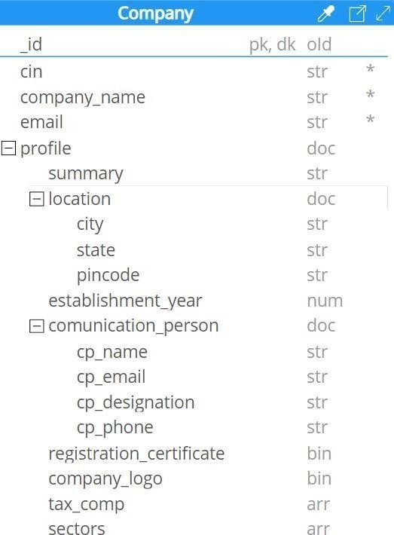

Fig 3.1.1 Data Dictionary

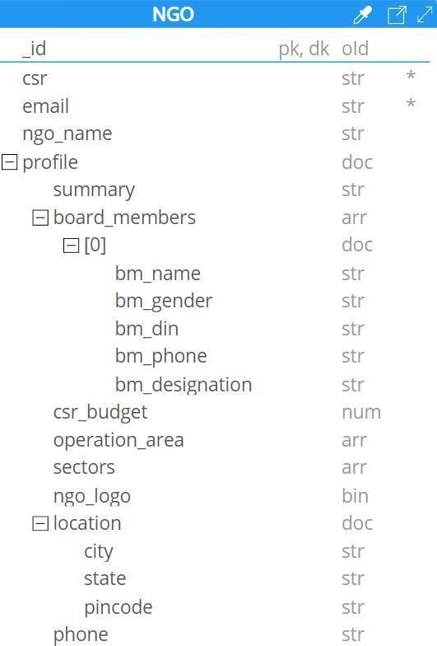

Fig 3.1.2 Data Dictionary (2)

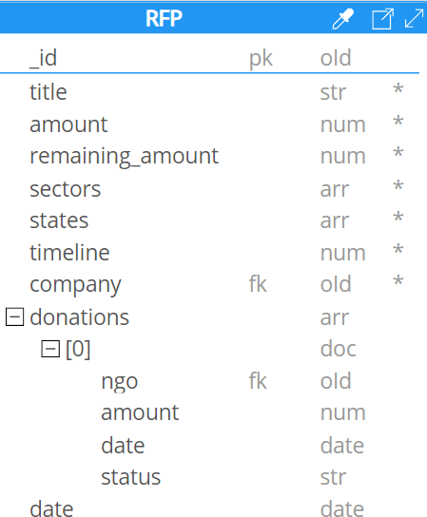

Fig 3.1.3 Data Dictionary (3)

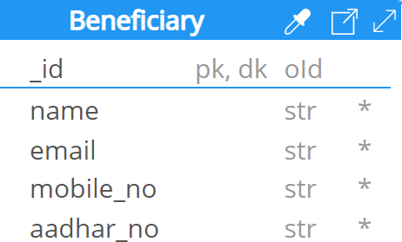

Fig 3.1.4 Data Dictionary (4)

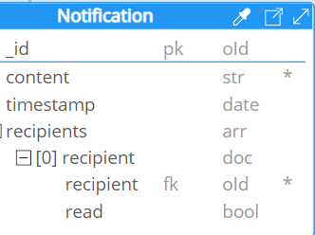

Fig 3.1.5 Data Dictionary (5)

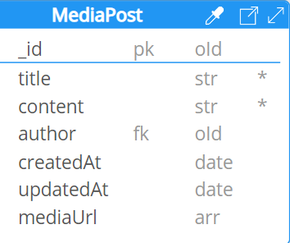

Fig 3.1.6 Data Dictionary (6)

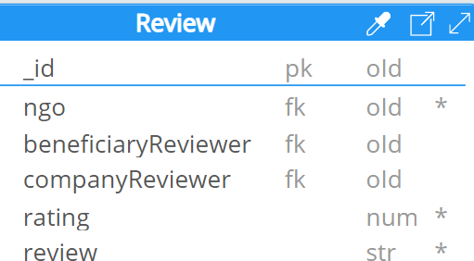

Fig 3.1.7 Data Dictionary (7)

## ER Diagram

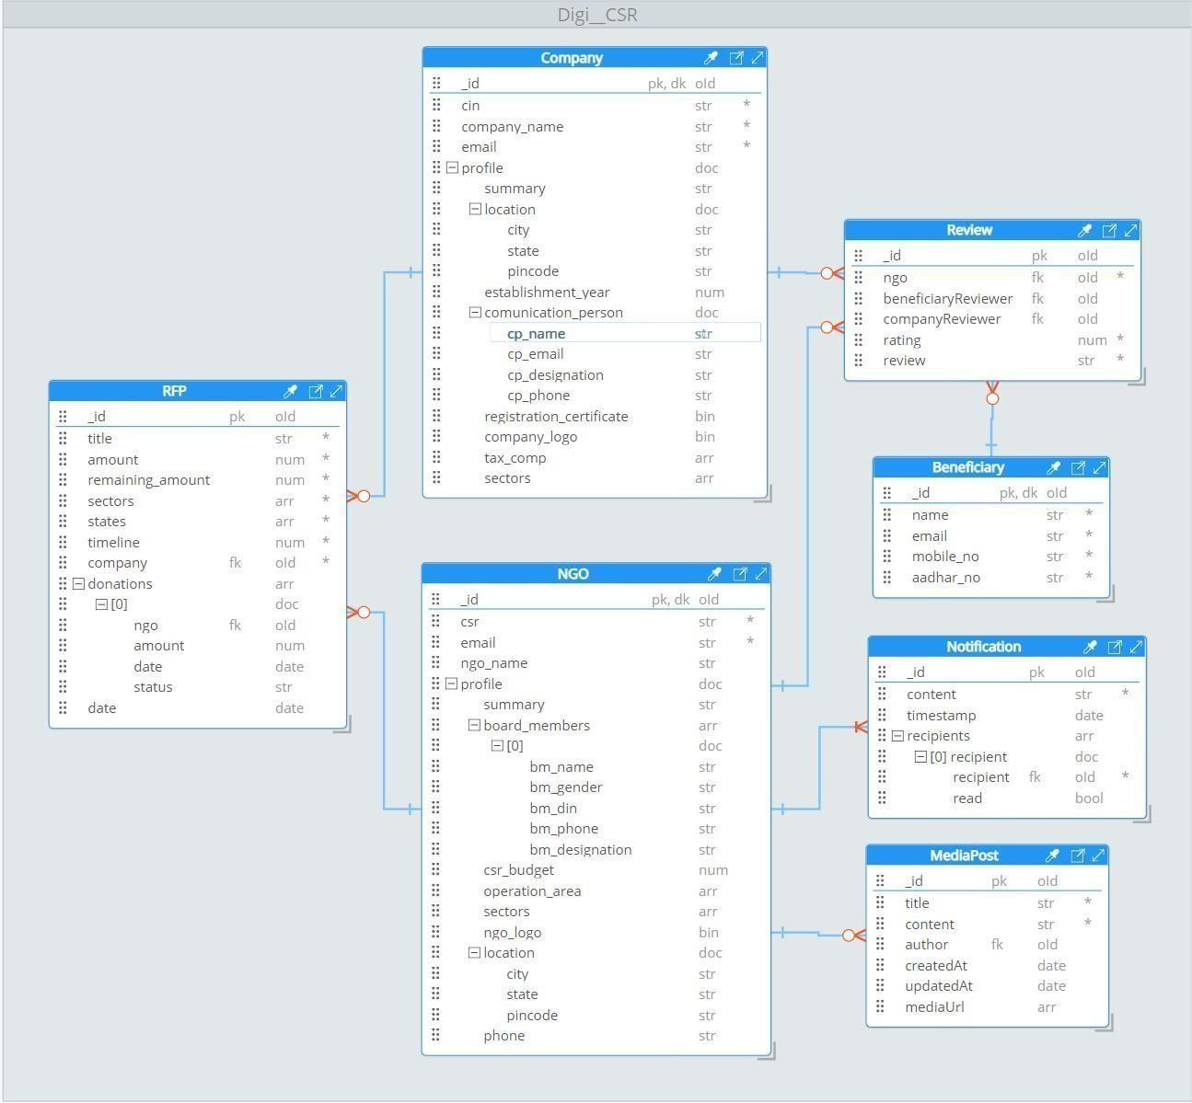

Fig 3.2.1 ER Diagram

# Chapter-4 Implementation Screenshots

* 1. **Beneficiary Side**

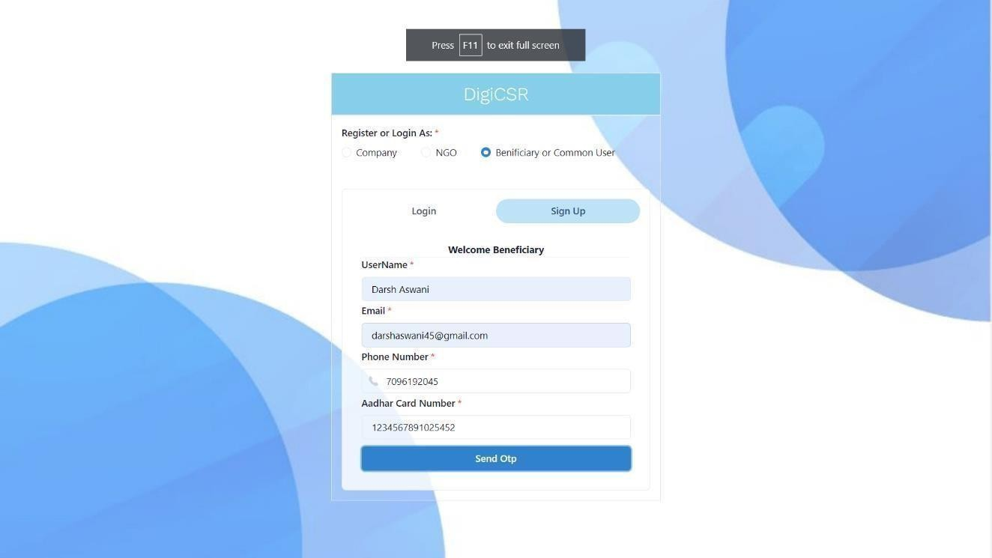

Fig 4.1.1 Beneficiary Sign UP

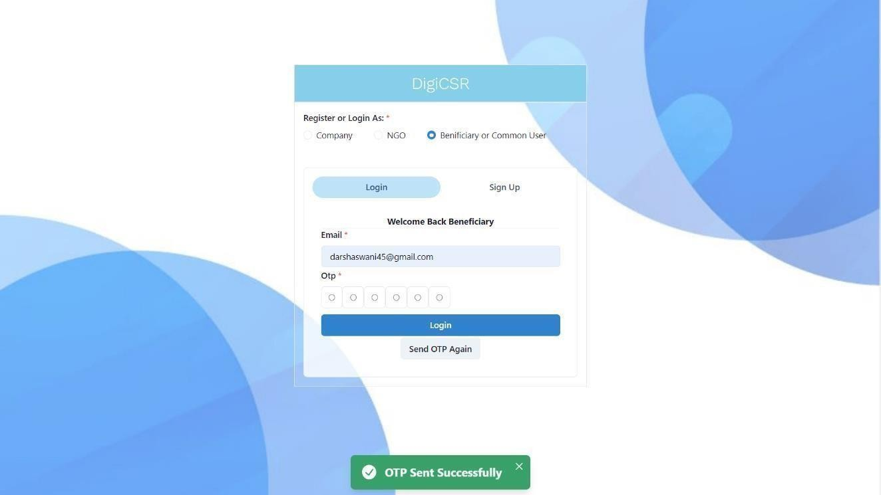

Fig 4.1.2 Beneficiary Login

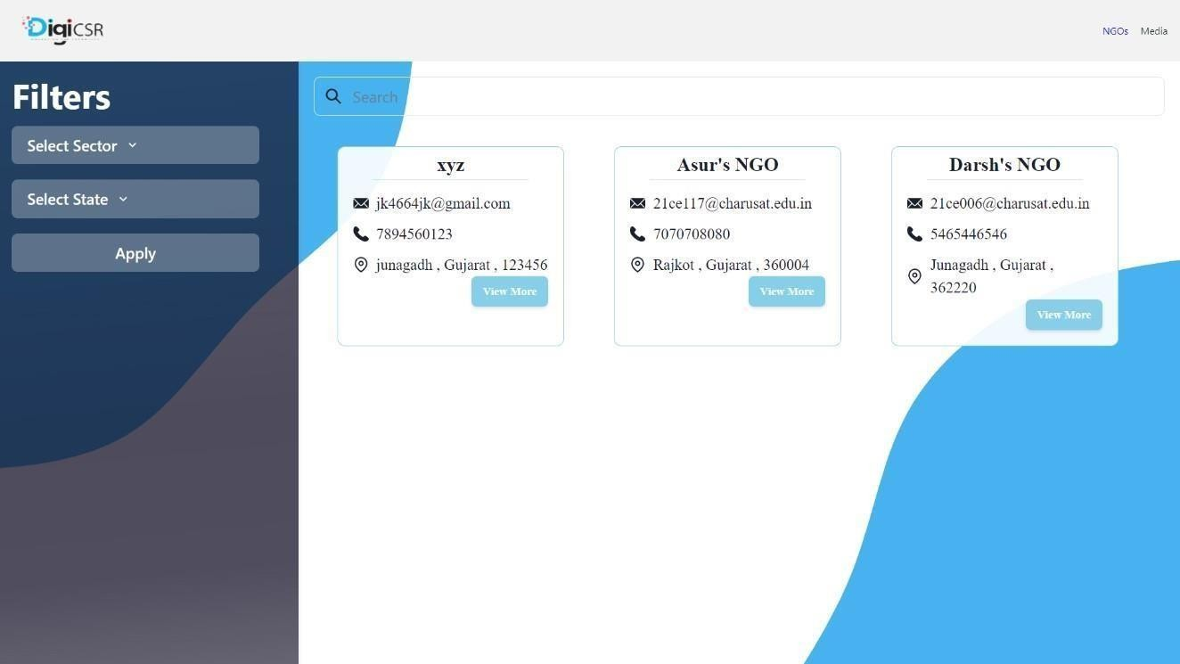

Fig 4.1.3 Beneficiary NGO list page

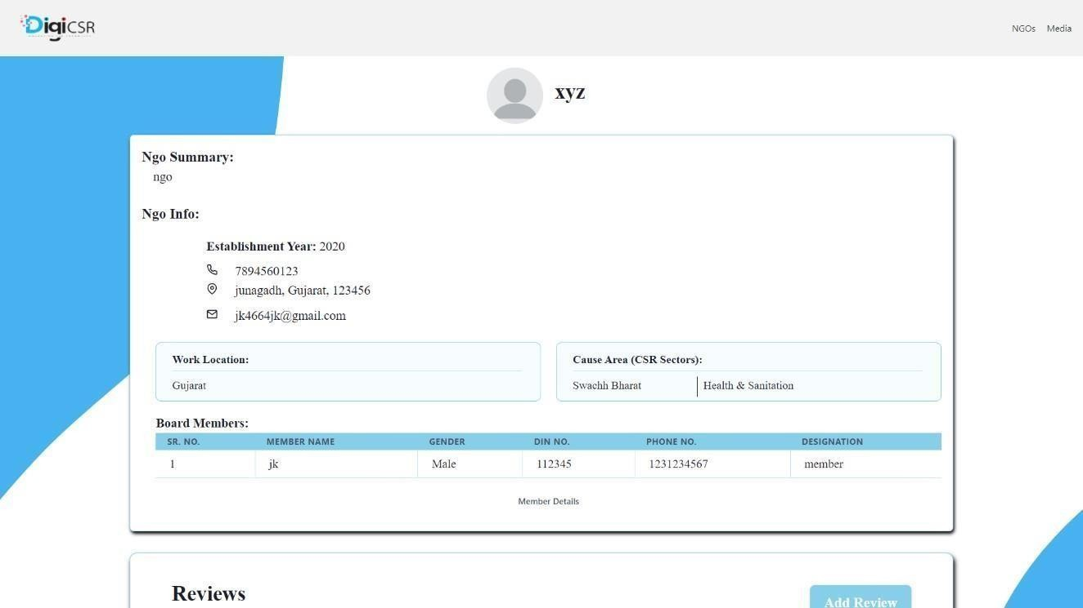

Fig 4.1.4 NGO Profile to Show to Beneficiary

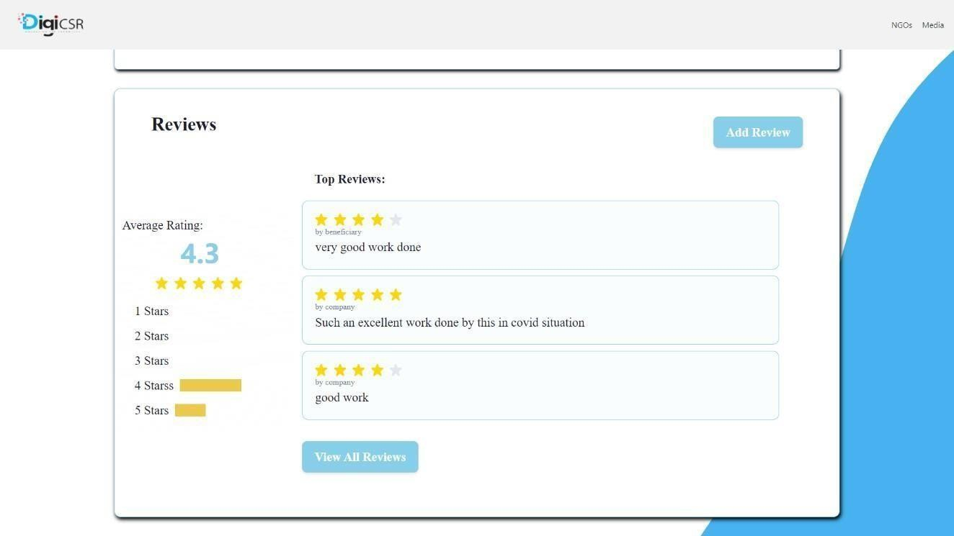

Fig 4.1.5 NGO Reviews to Show to Beneficiary

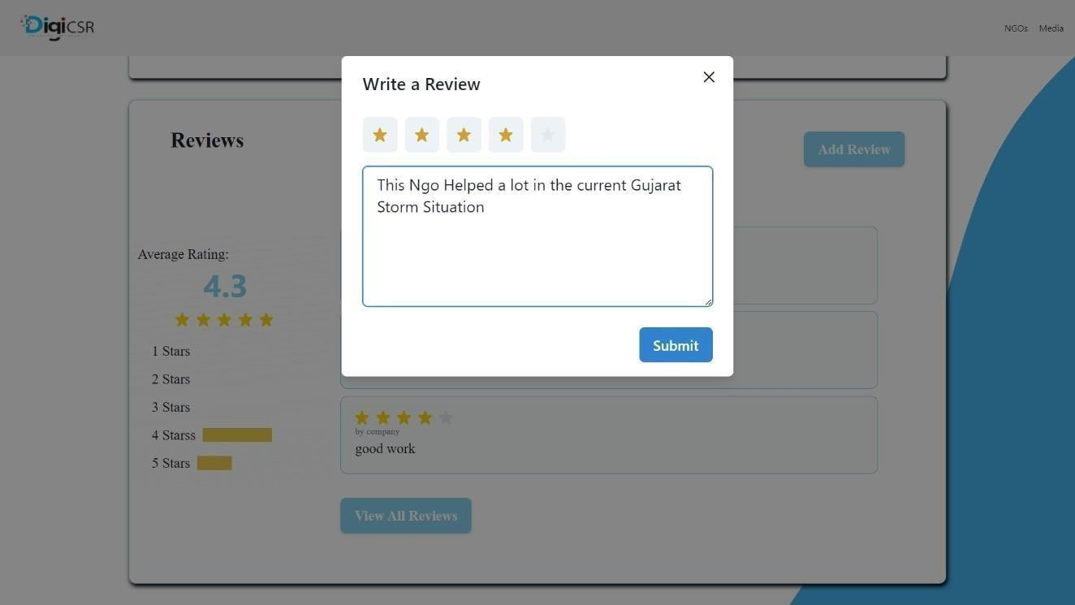

Fig 4.1.6 Give review to NGO form



Fig 4.1.7 Social Works Blogs Posted By NGO



Fig 4.1.8 Blogs Detailed View

# Company Side

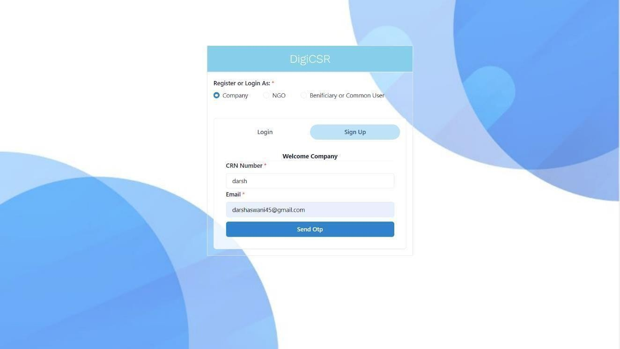

Fig 4.2.1 Company Sign UP

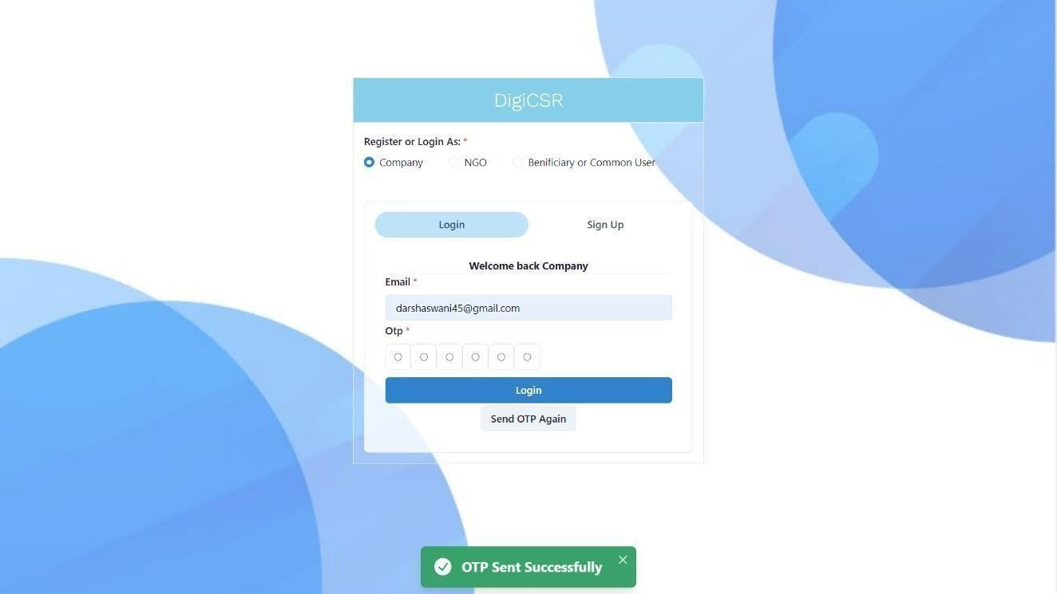

Fig 4.2.2 Company Login

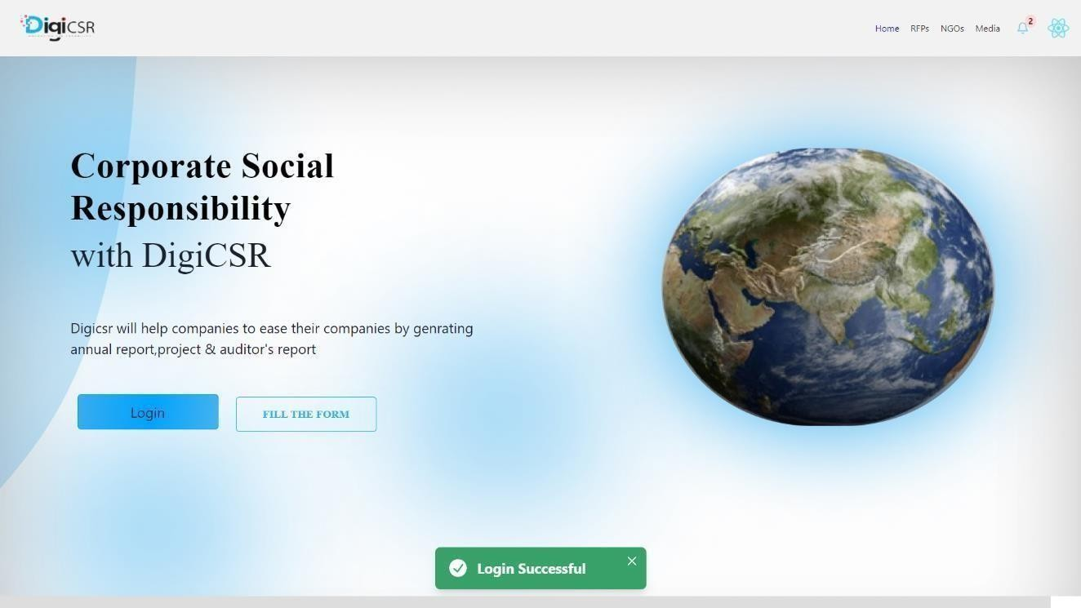

Fig 4.2.3 Company Home Page (1)

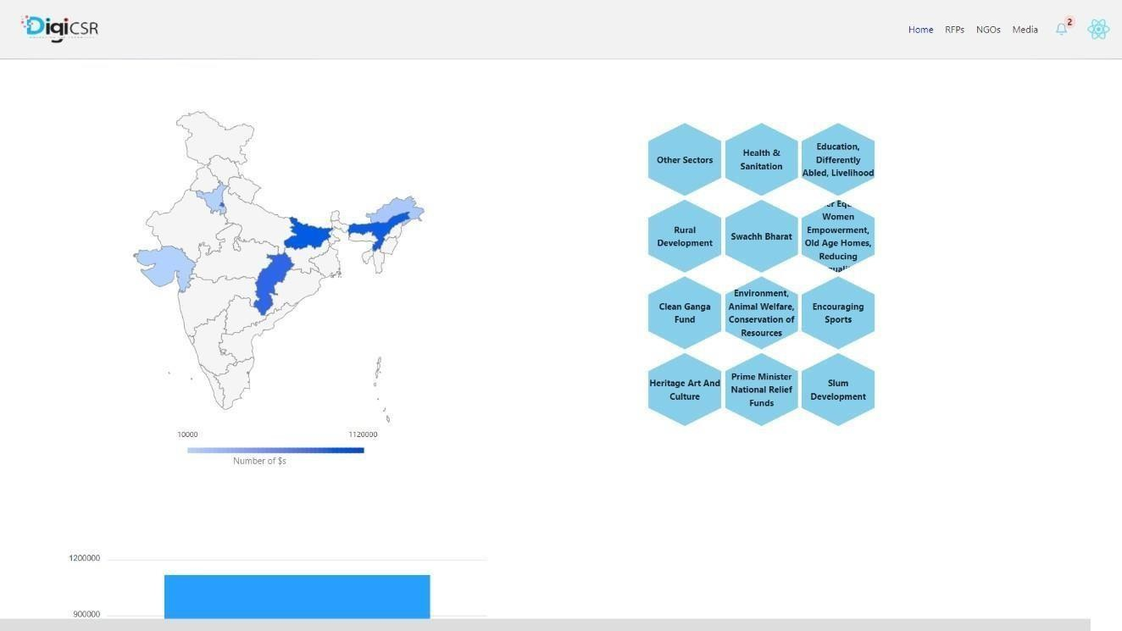

Fig 4.2.3 Company Home Page (2)

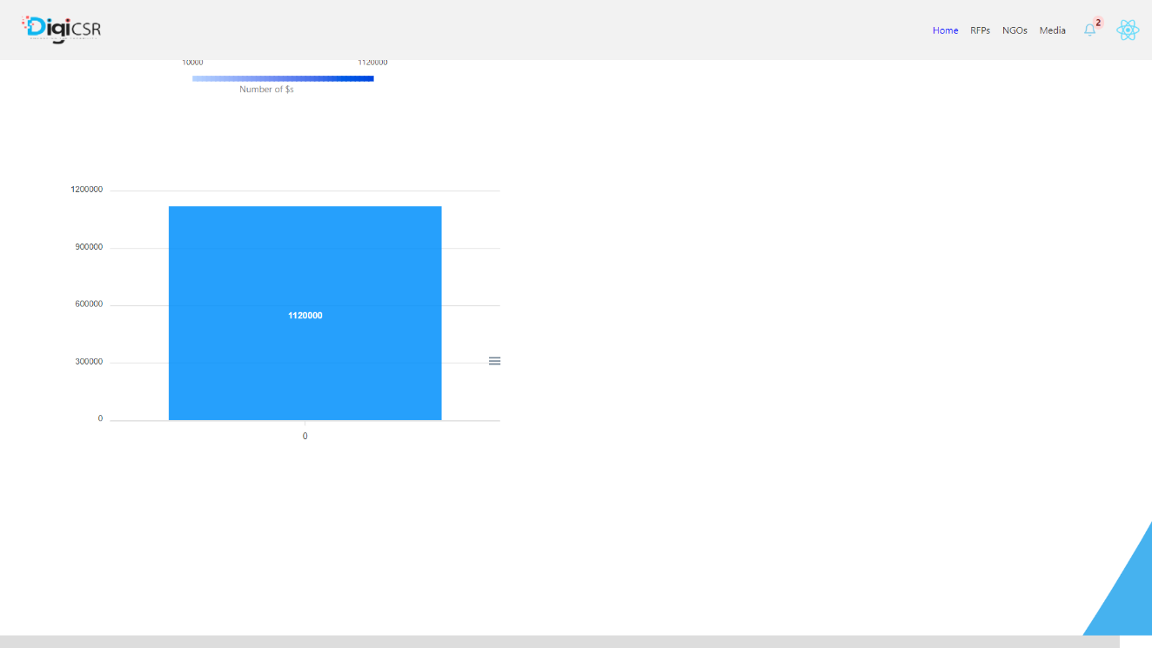

Fig 4.2.3 Company Home Page (3)

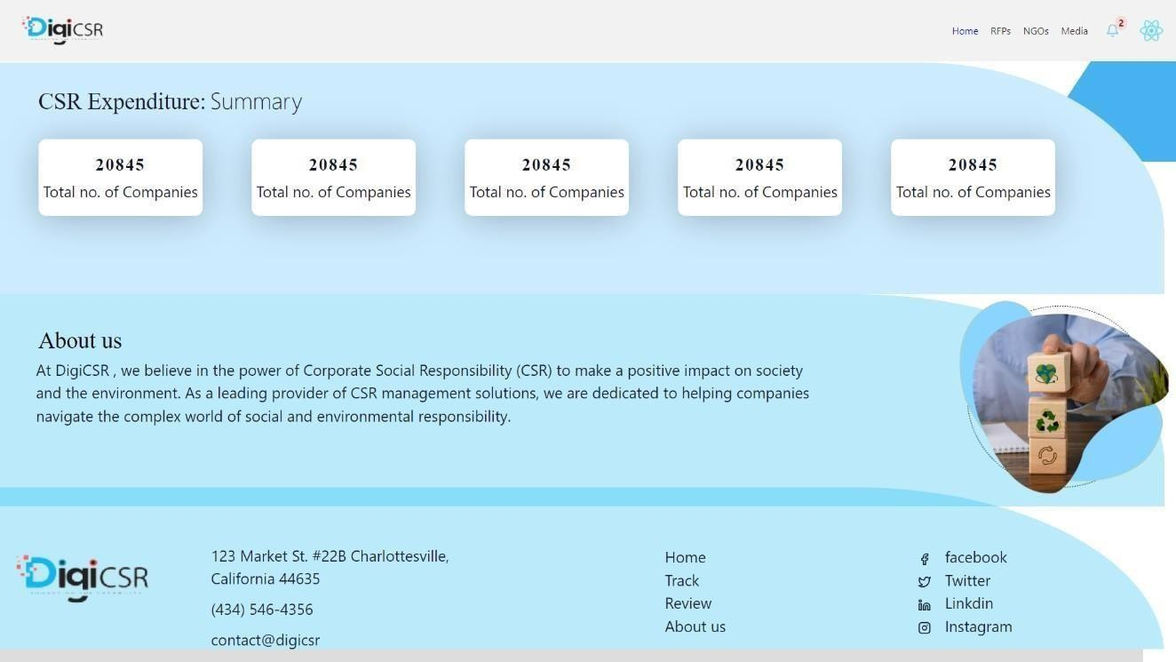

Fig 4.2.3 Company Home Page (4)

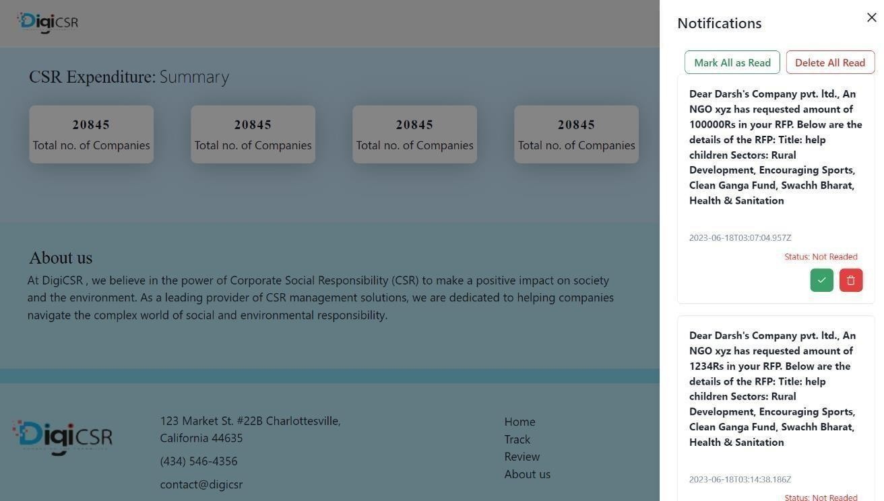

Fig 4.2.4 Company Notifications

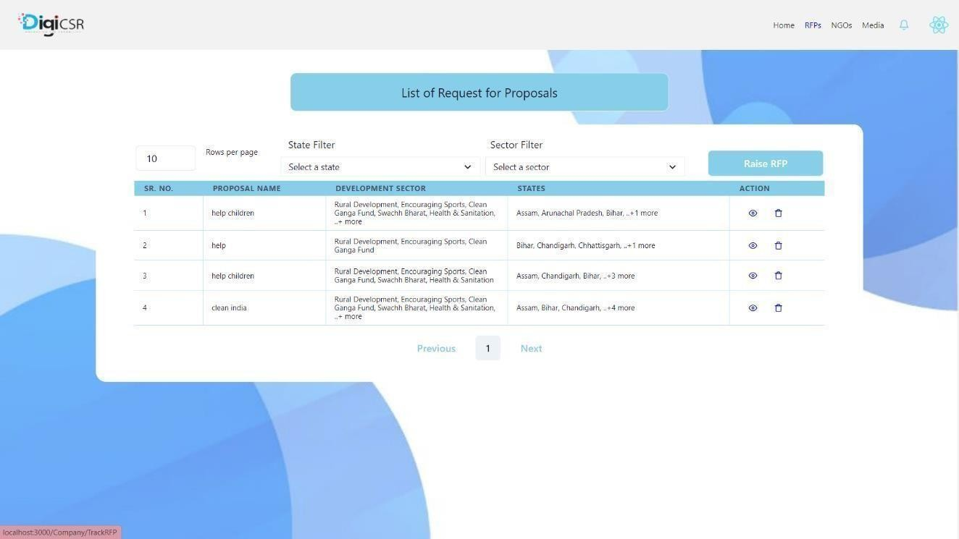

Fig 4.2.5 Company Raised RFP Table

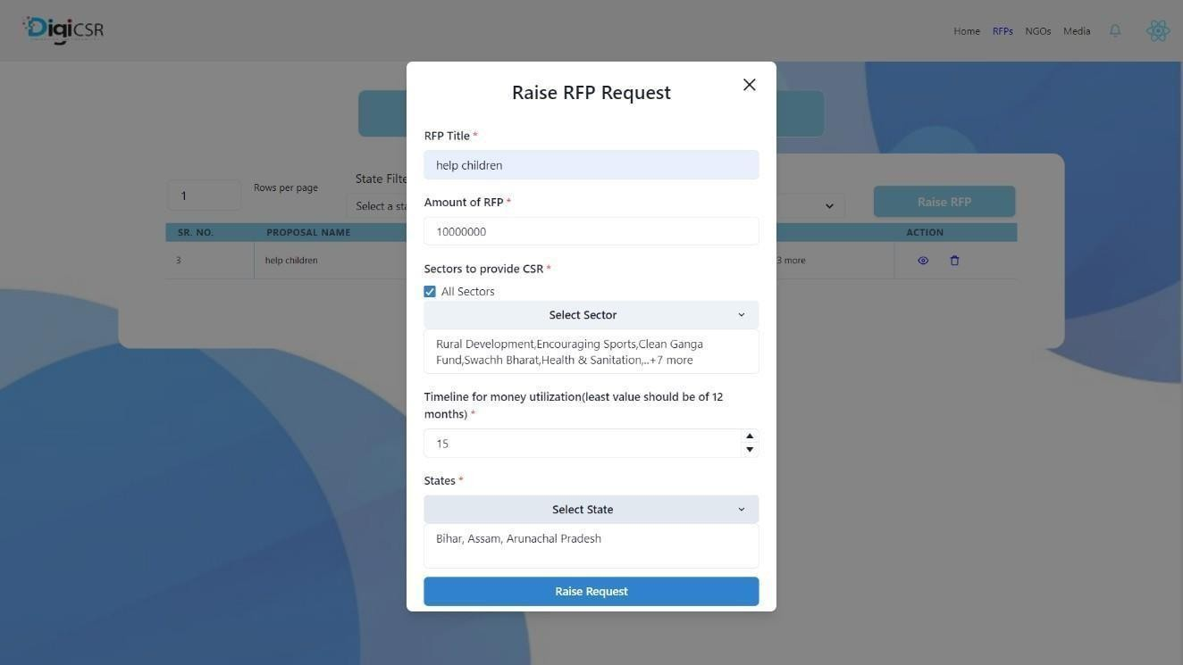

Fig 4.2.6 Company Raise RFP Form

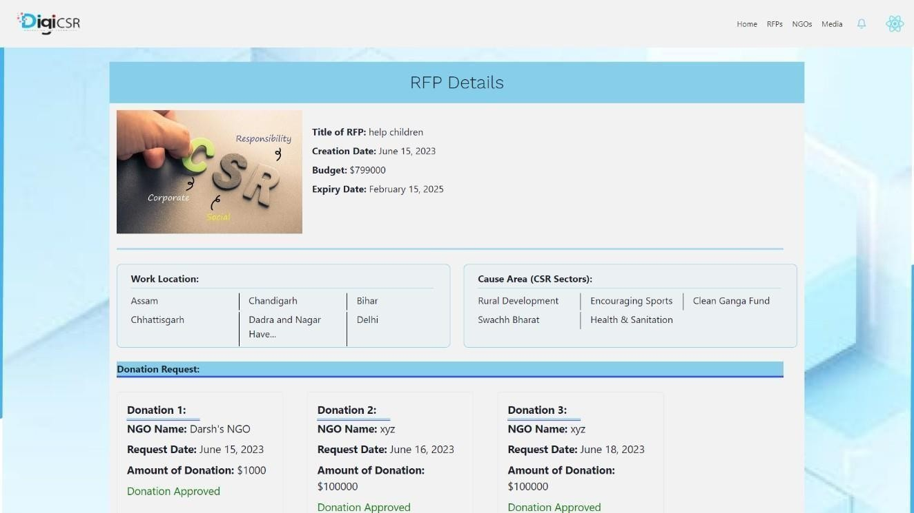

Fig 4.2.7 Company Raised RFP Details (1)

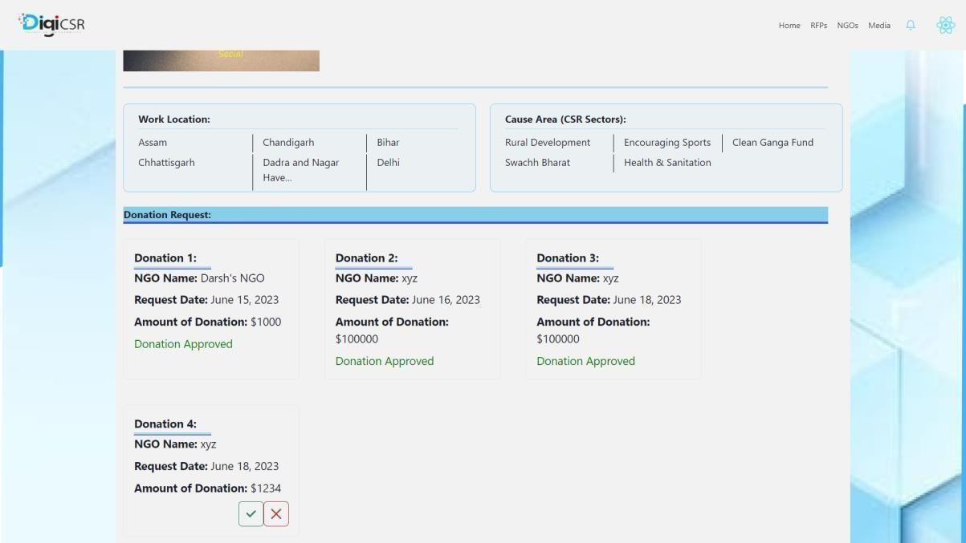

Fig 4.2.7 Company RFP Details (2)

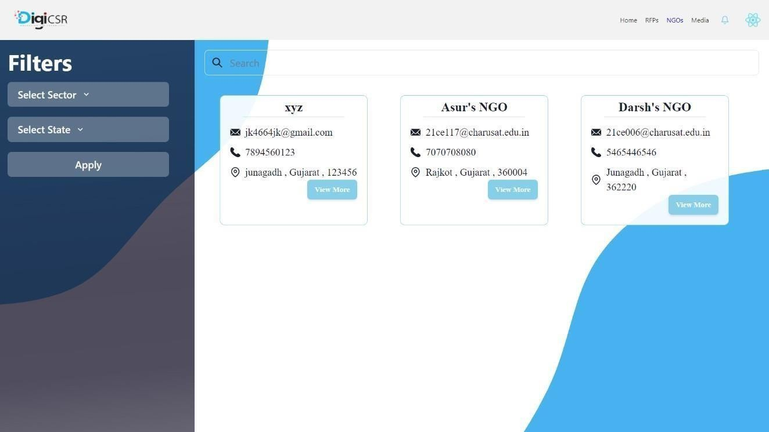

Fig 4.2.8 Company list of NGOs

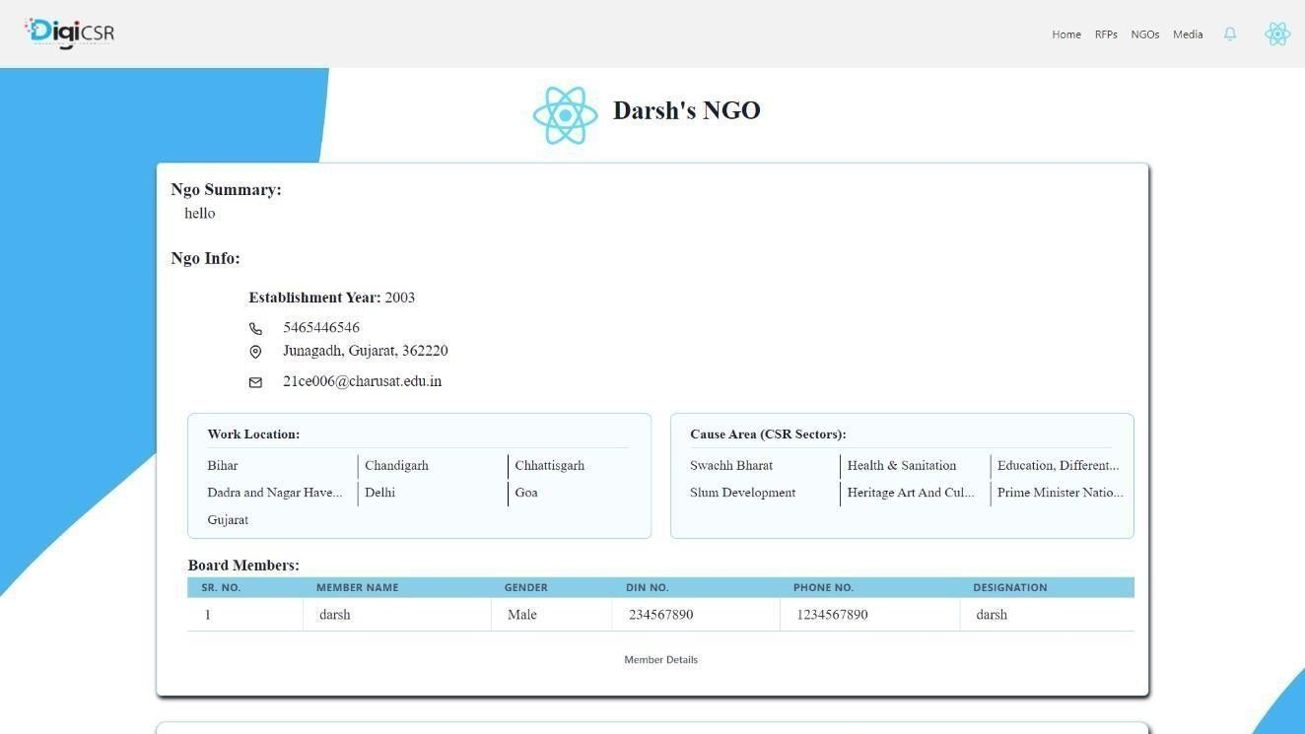

Fig 4.2.9 NGO Profile for showing to Company

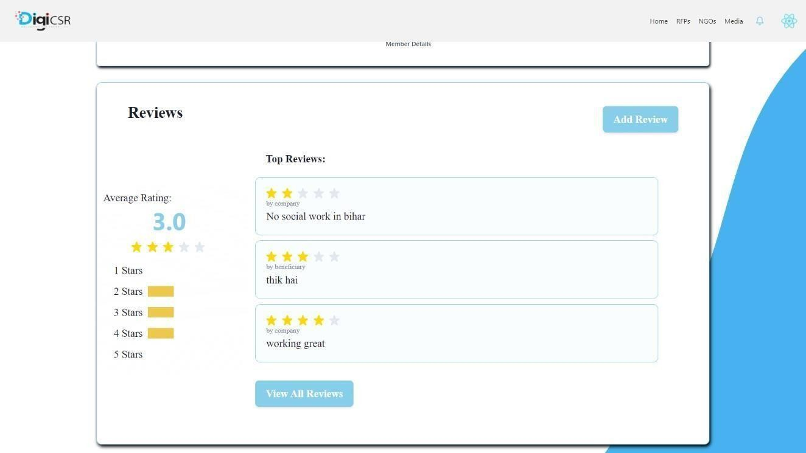

Fig 4.2.10 NGO Reviews for showing to Company

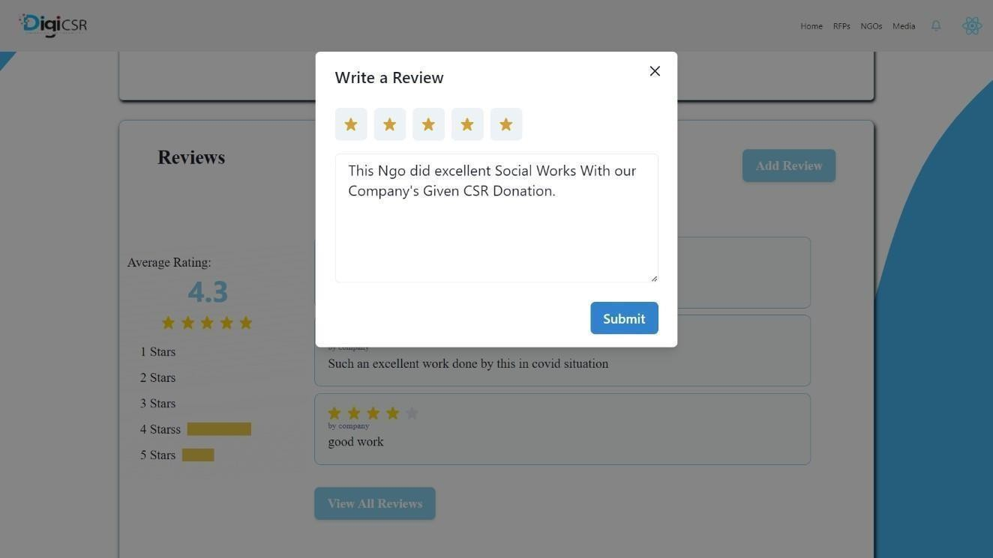

Fig 4.2.11 Company Review to NGO form



Fig 4.2.12 Social Works Blogs Posted By NGO

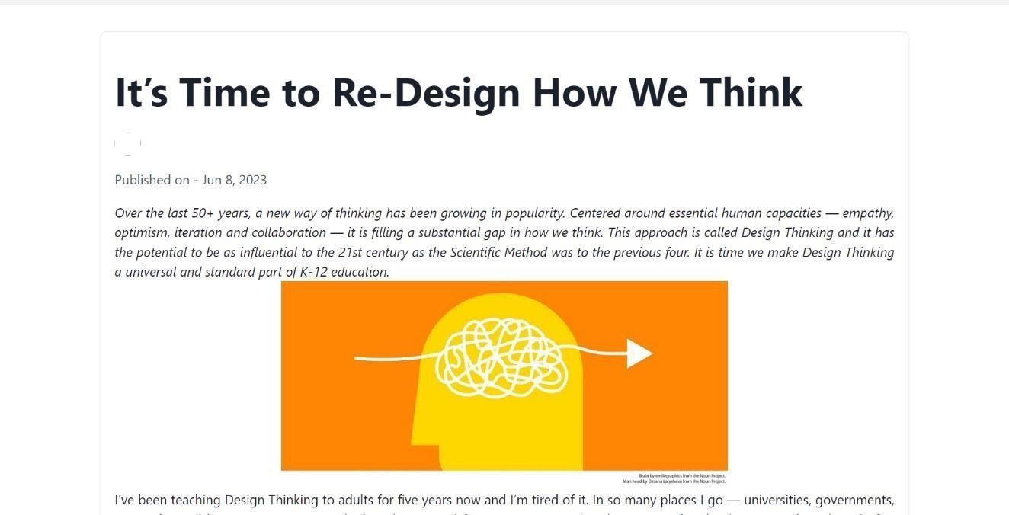

Fig 4.2.13 Detailed view of Blog

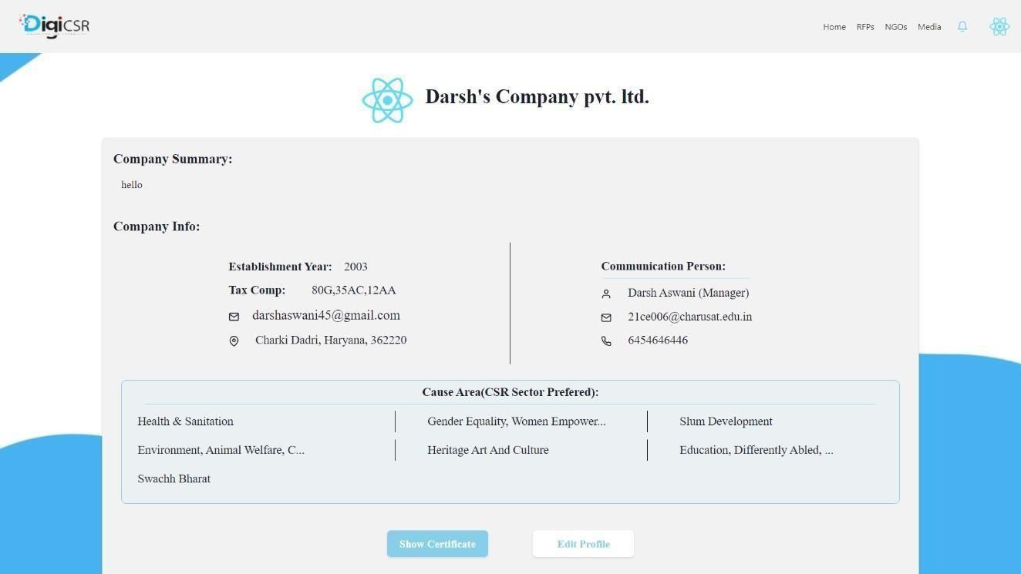

Fig 4.2.14 Company Profile

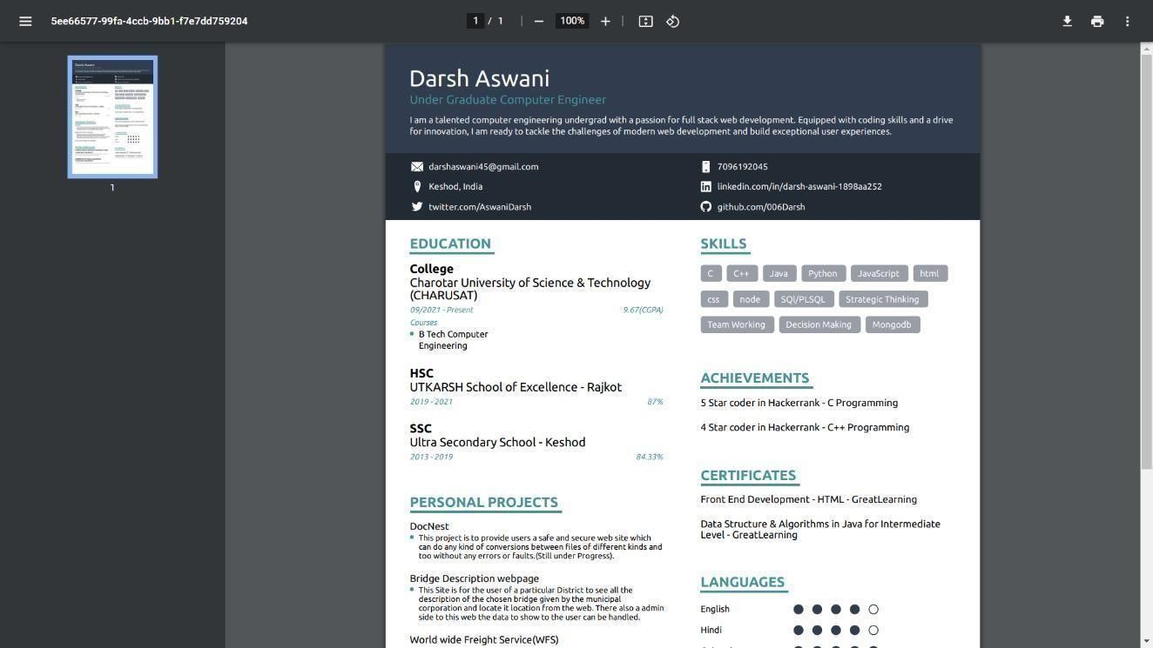

Fig 4.2.15 Company Registration Certificate

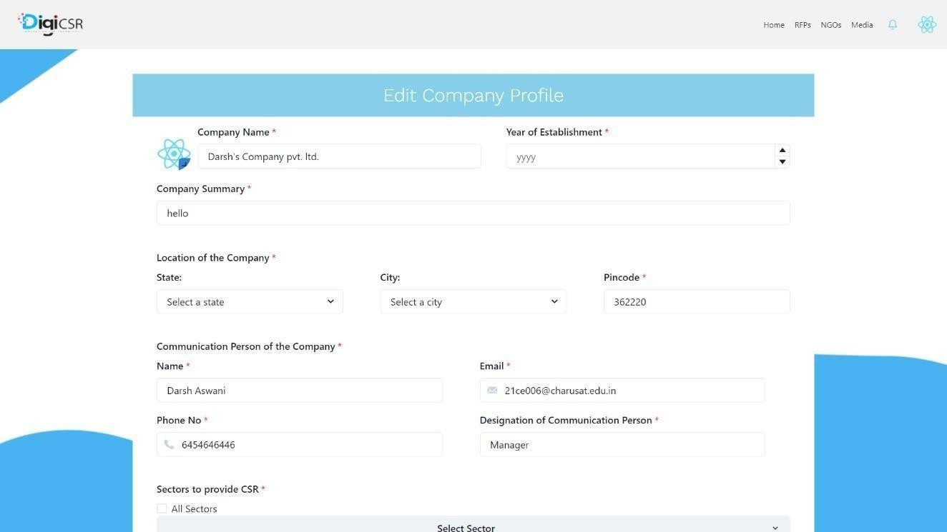

Fig 4.2.16 Company Edit Profile form (1)

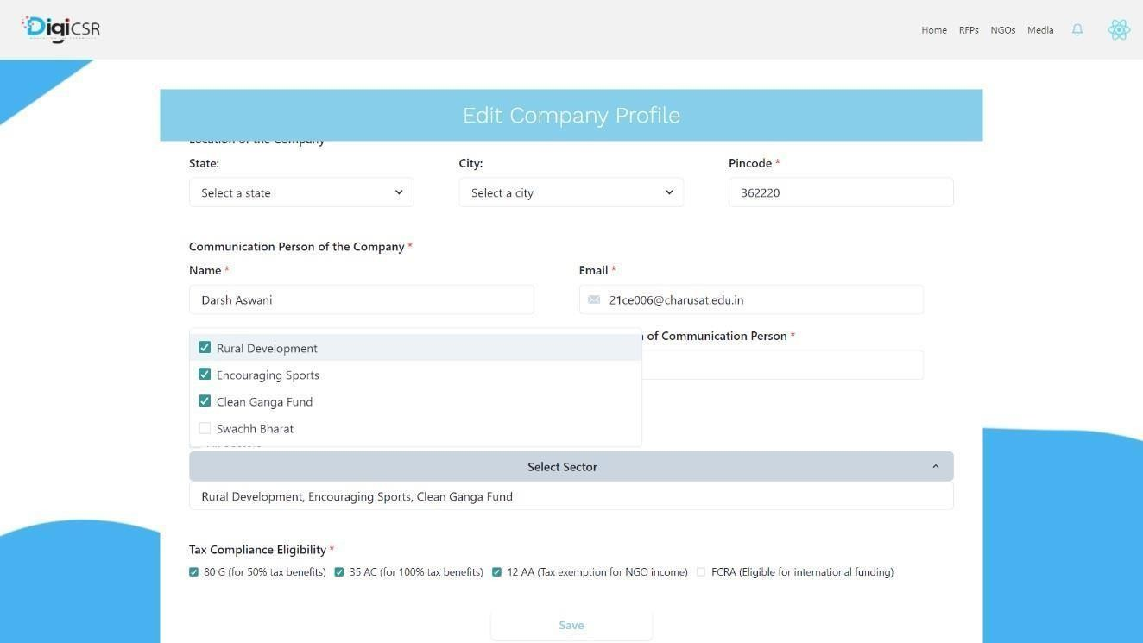

# NGO Side

Fig 4.2.16 Company Edit Profile form (1)

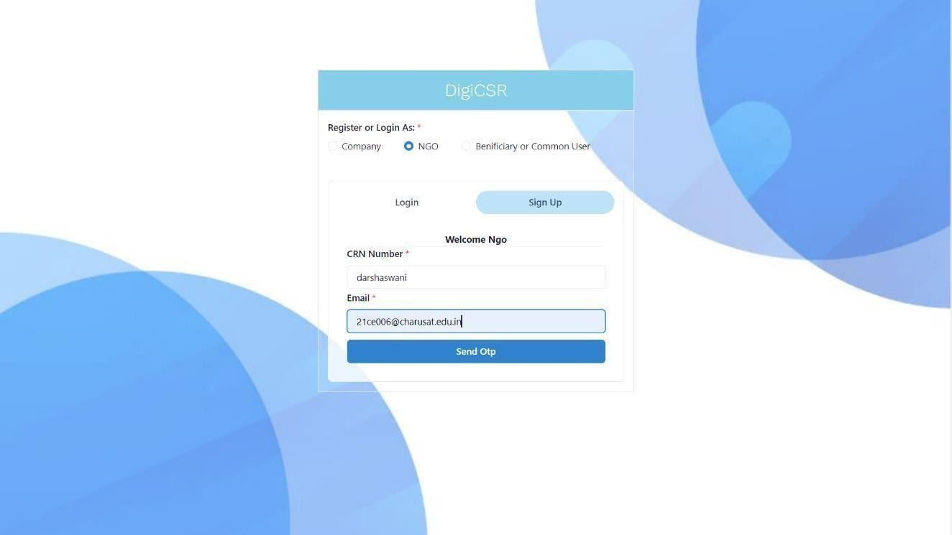Fig 4.3.1 NGO Sign UP

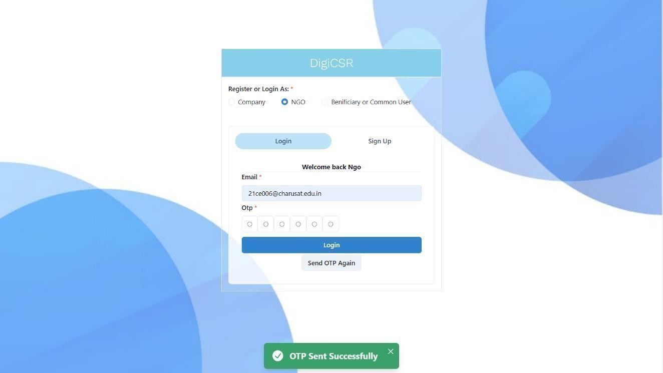

Fig 4.3.2 NGO Login

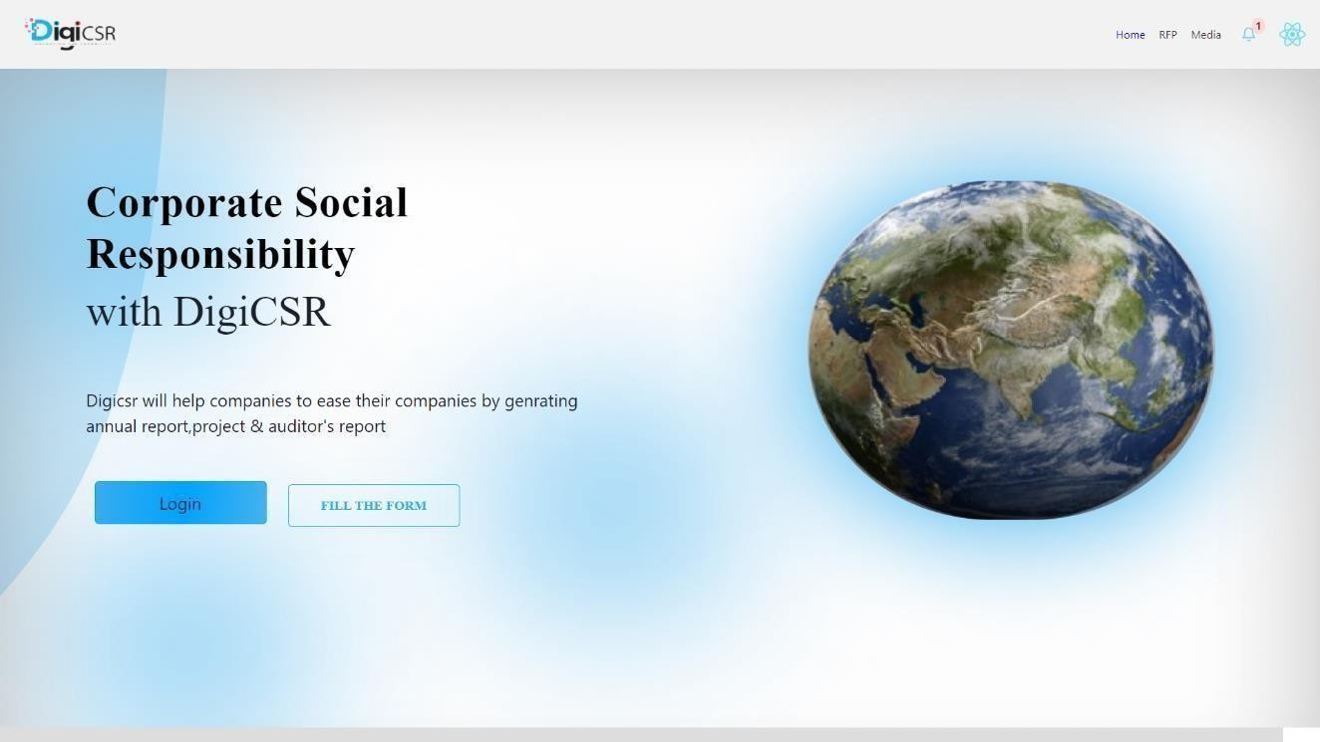

Fig 4.3.3 NGO Home Page (1)

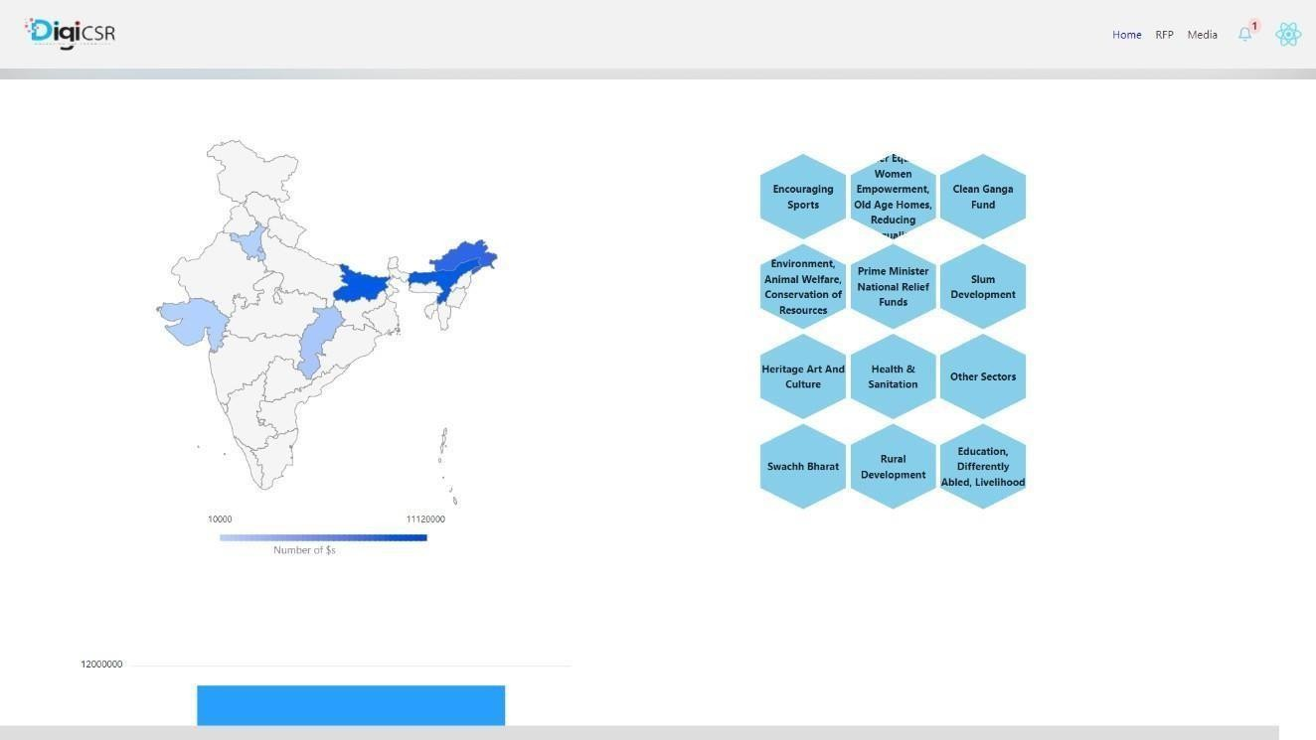

Fig 4.3.3 NGO Home Page (2)

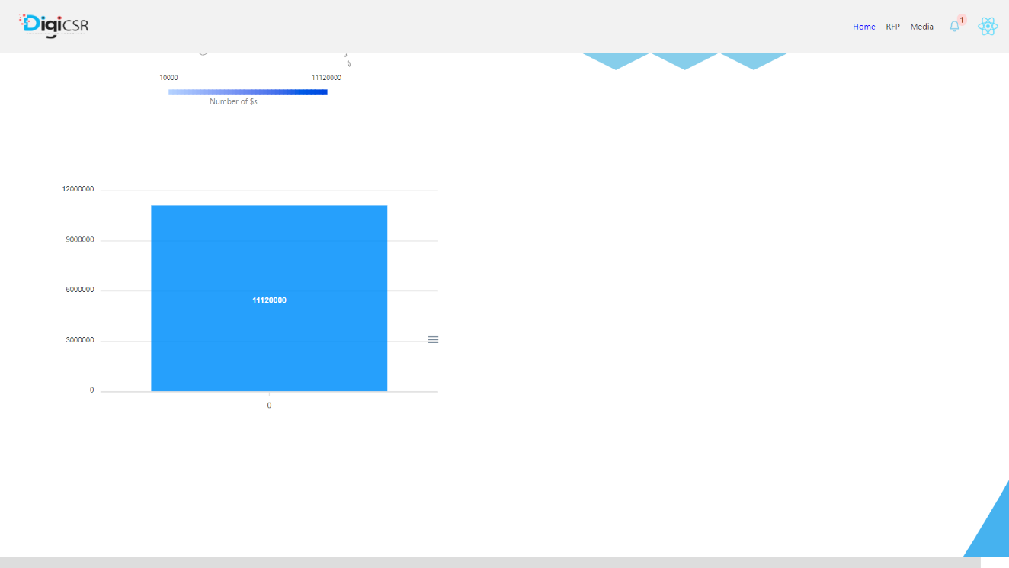

Fig 4.3.3 NGO Home Page (3)

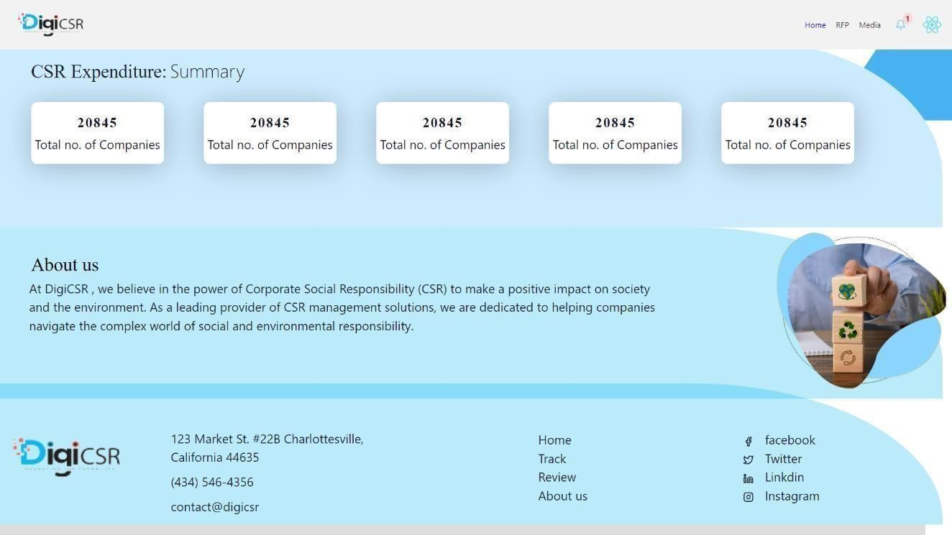

Fig 4.3.3 NGO Home Page (4)

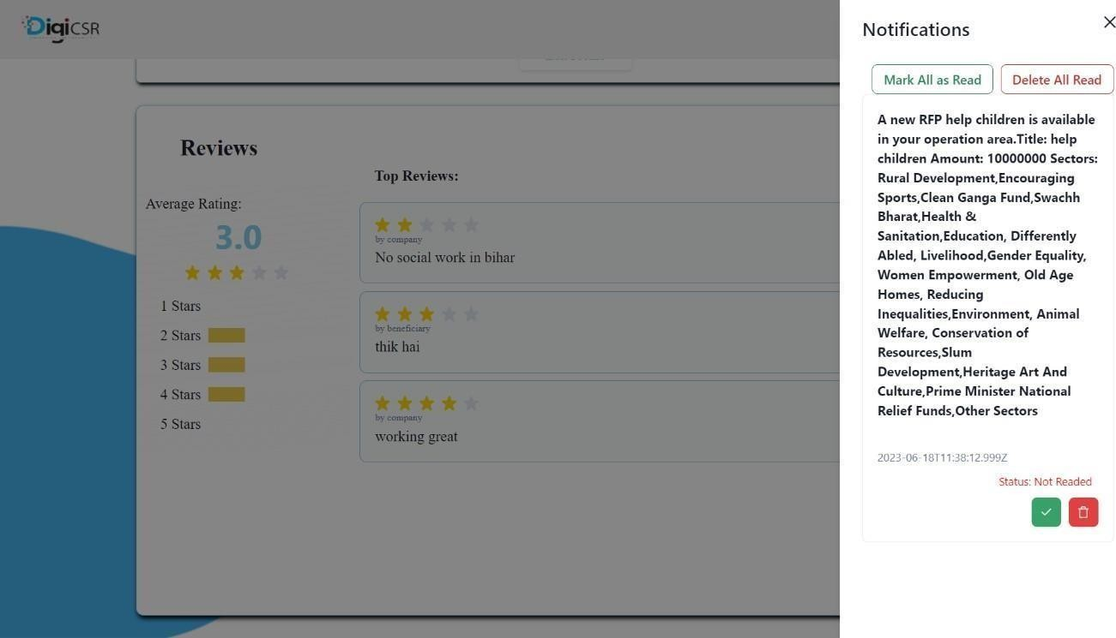

Fig 4.3.4 NGO Notifications

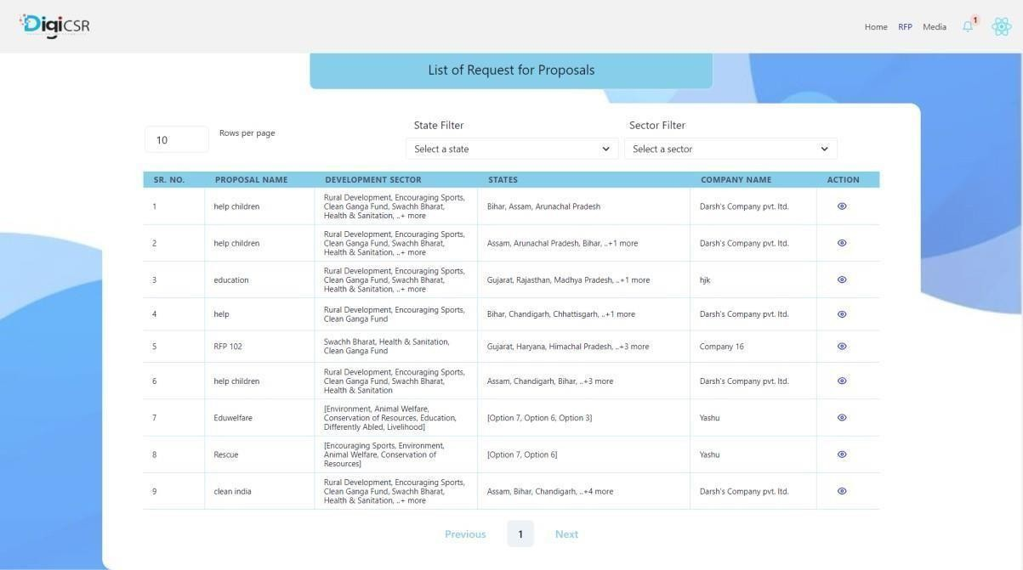

Fig 4.3.5 NGO RFP Table

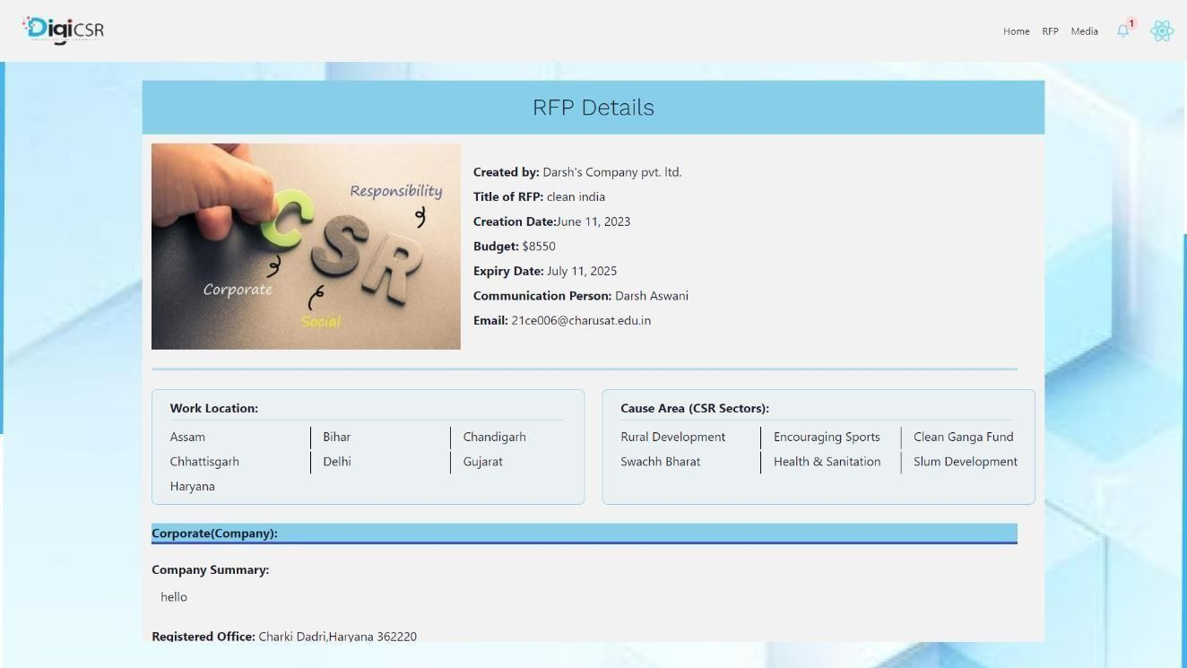

Fig 4.3.6 NGO Raised RFP Details (1)

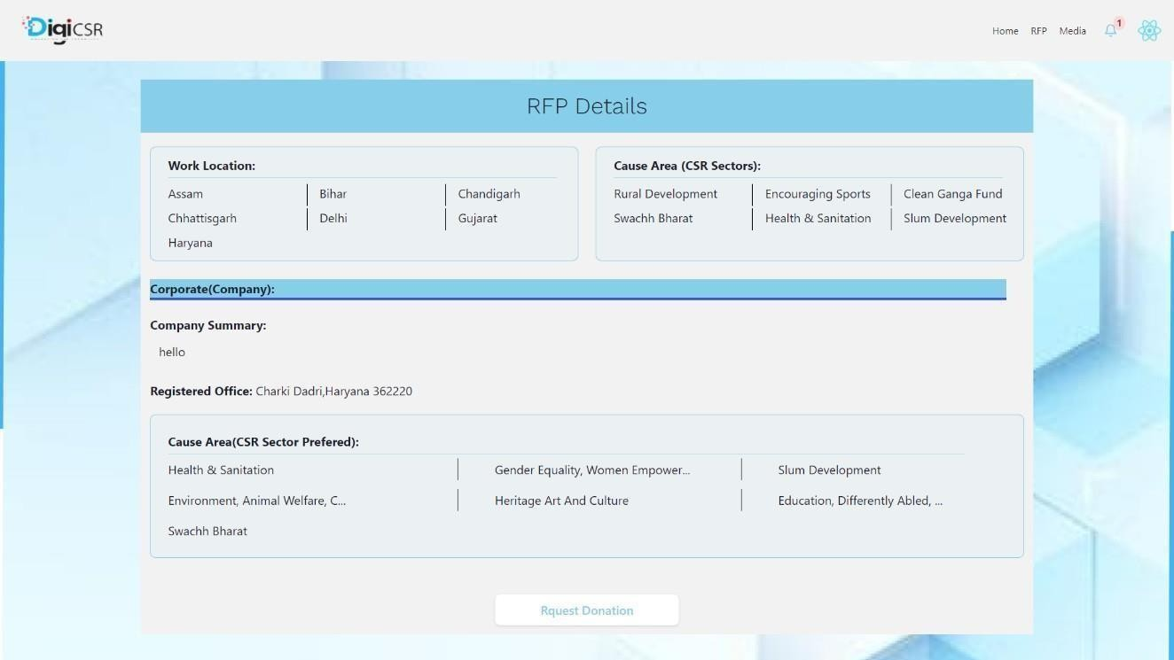

Fig 4.3.6 NGO Raised RFP Details (2)

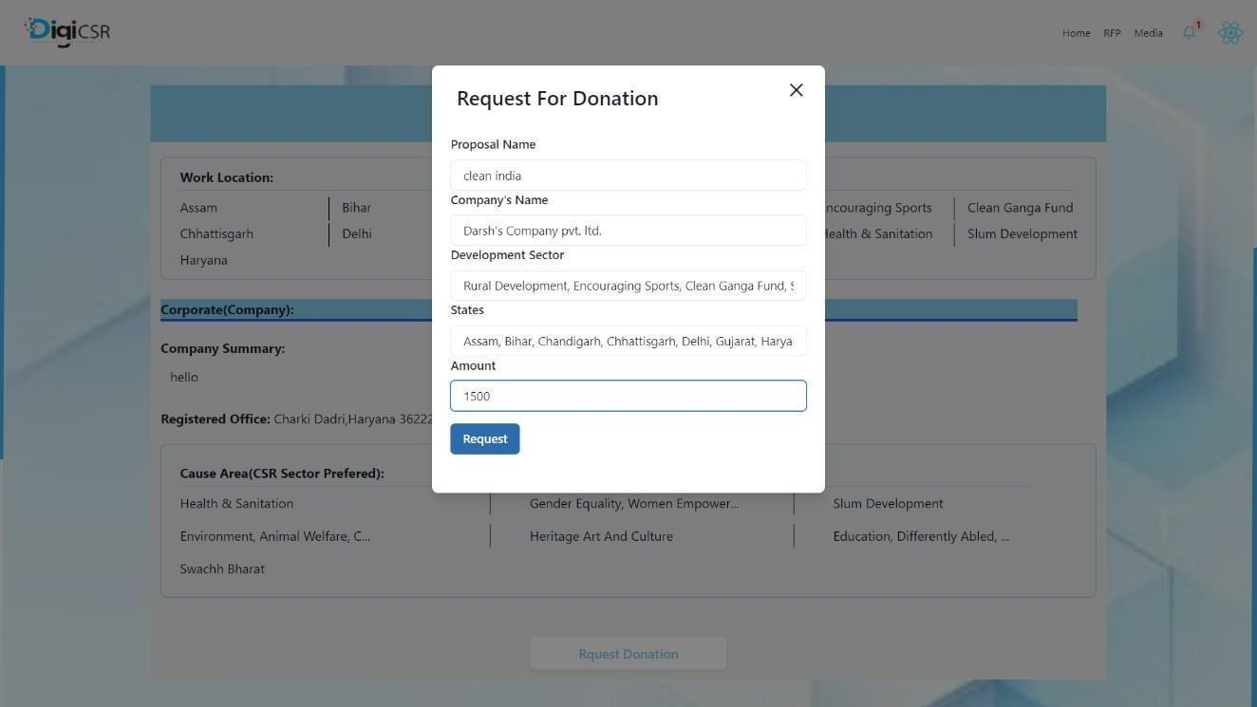

Fig 4.3.7 NGO Request Donation in RFP form

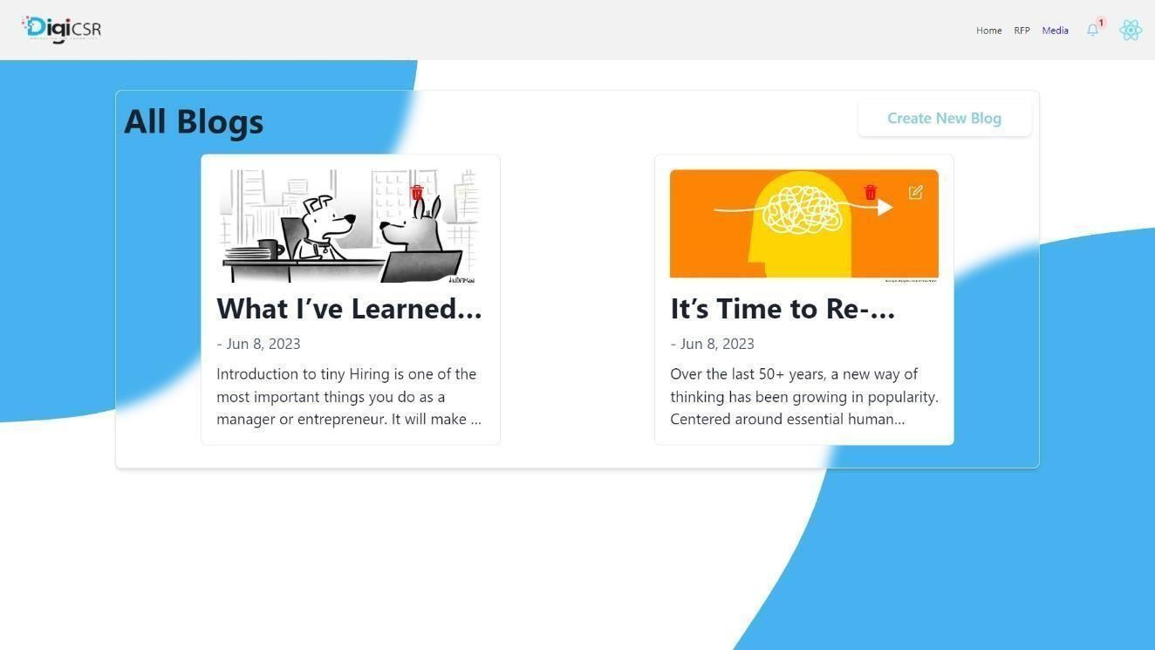

Fig 4.3.8 NGO list of Posted Blogs

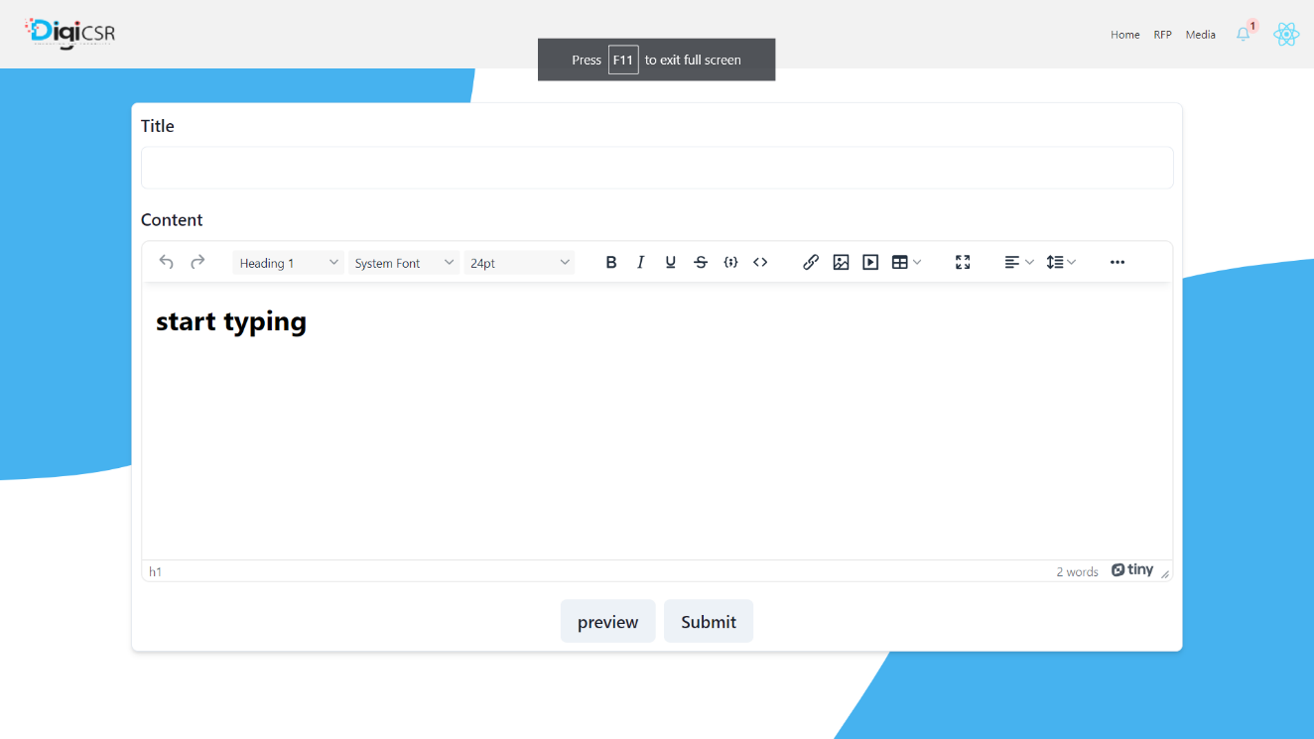

Fig 4.3.9 NGO post Blogs of the social work

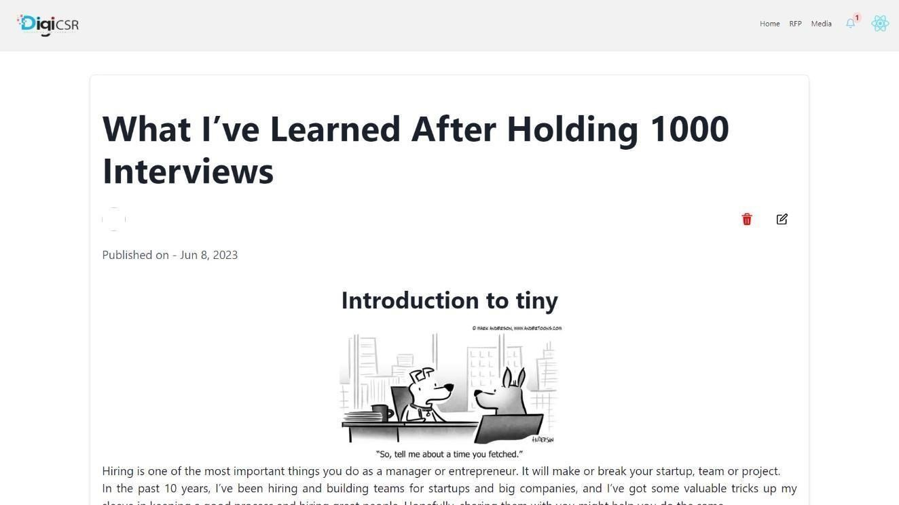

Fig 4.3.10 NGO Blogs Detailed View

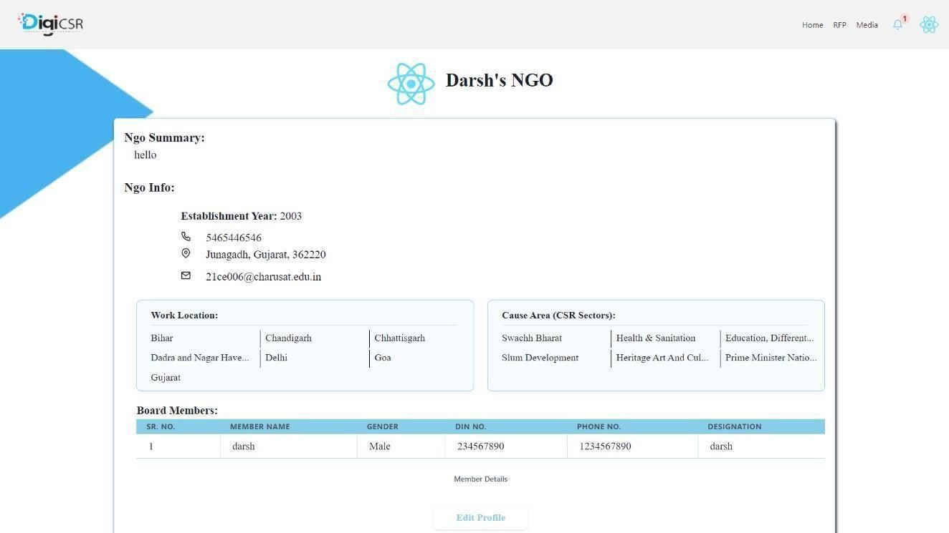

Fig 4.3.11 NGO Profile

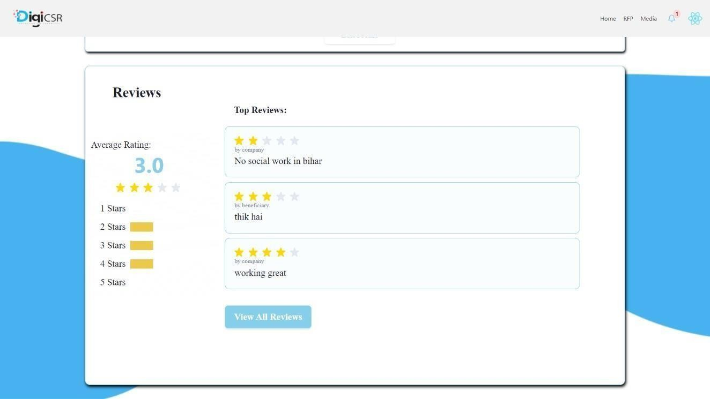

Fig 4.3.12 Reviews Given to NGO From Company and Beneficiary

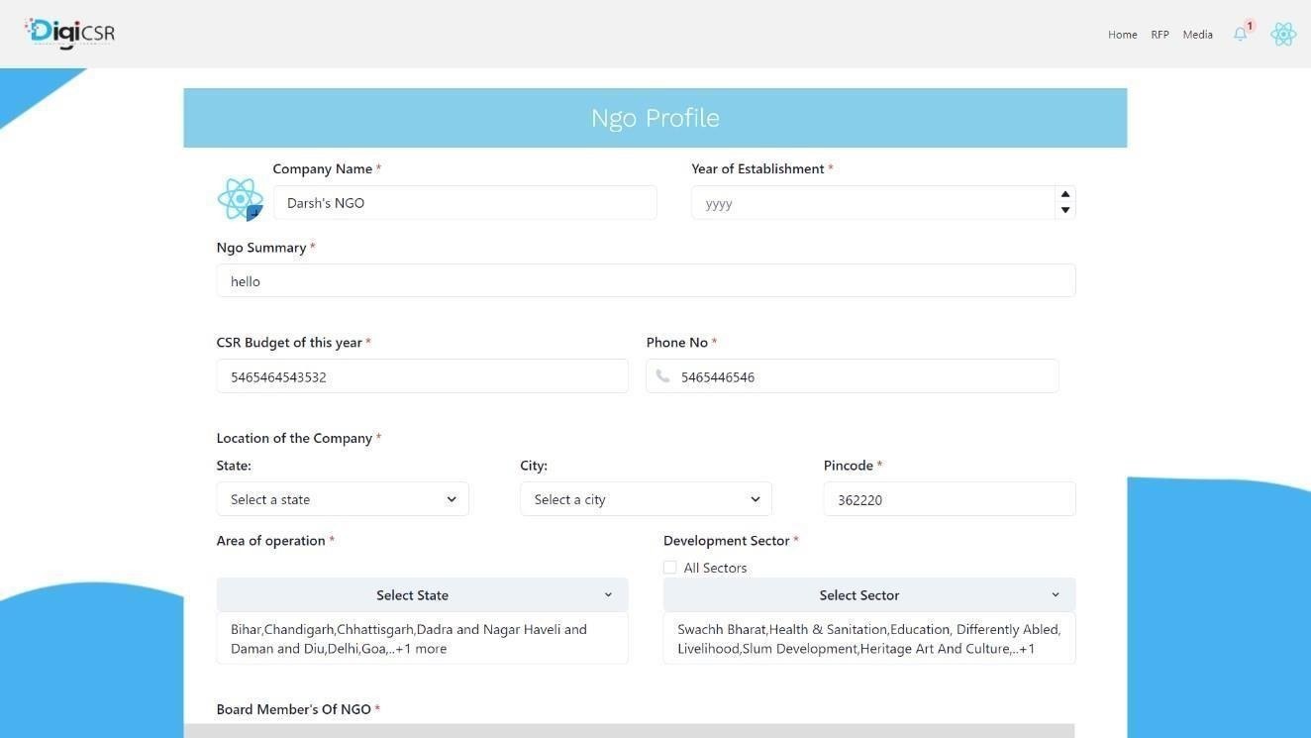

Fig 4.3.13 NGO edit profile form (1)

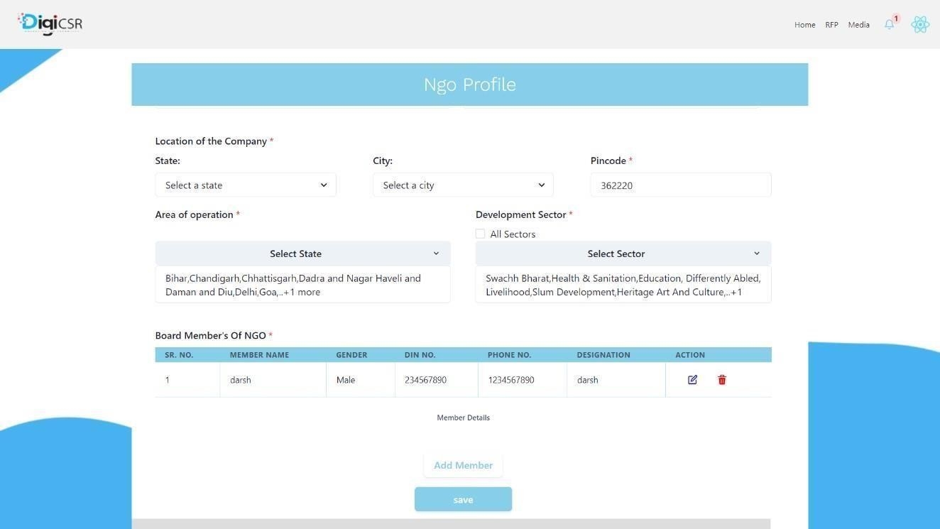

Fig 4.3.13 NGO edit profile form (2)

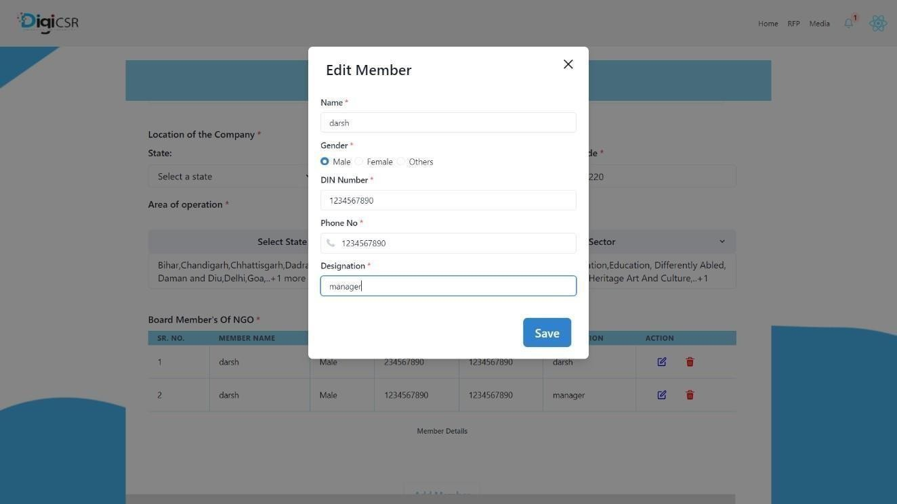

Fig 4.3.13 NGO edit profile form(Add/Edit Board Members of NGO form) (3)

# Chapter-5 Test Cases

## 5.1 Testing Strategy

In this project unit testing was carried out and each section were tested one by one.

Module Name : **Registration of Company, NGO and Beneficiary**

Table 5.1.1 Registration of Company, NGO, Beneficiary test cases

|  |  |  |  |  |  |  |  |
| --- | --- | --- | --- | --- | --- | --- | --- |
| **Test case**  **scenarios** | **Test case**  **Name** | **Pre-**  **condition** | **Testing**  **Steps** | **Testing**  **Data** | **Expected**  **Result** | **Post**  **Condition** | **Status** |
| (Company Registration) Enter the CIN number and Email id | Company Registrat  ion | CIN number and email should be registered in CRN table and User must be accessing Company sign up page | Enter all required values for test cases | Enter valid Email and CIN  number | Pop up message – OTP sent to your email | OTP field will be shown | PASS |
| Enter invalid Email and CIN  number | Error message is show | Reload the register page | PASS |
| (NGO  Registration) Enter the CRN  number and Email id | NGO  Registrat ion | CSR number and email should be registered in CRN table and User must be accessing  NGO sign up page | Email, CSR  number | Pop up message – OTP sent to your email | OTP field will be shown | PASS |
| Enter invalid Email and CSR  number | Error message is show | Reload the register page | PASS |
| (Beneficiary Registration) Enter the CIN number and Email id | Beneficiary Registrat ion | User must be accessing Beneficiary sign up page | Enter all required values for test cases | Enter valid Email, name, Mobile NO,  Aadhar No | Pop up message – OTP sent to your email | OTP field will be shown | PASS |
| Enter invalid Email | Error message is show | Reload the register page | PASS |

|  |  |  |  |  |  |  |  |
| --- | --- | --- | --- | --- | --- | --- | --- |
| Enter OTP while registration of Company, NGO or Beneficiary | OTP  verification for Company, NGO or Beneficiary | Must get Pop up message – OTP sent to your email | Enter all required values fortest cases | OTP | User is registered and dashboard  for particular user is open | Dashboard will be shown as per the user | PASS |
| Enter invalid OTP or leave OTP  field empty | Pop up message – Invalid OTP | OTP field will show again | PASS |

Module Name : **Login of Company, NGO and Beneficiary**

Table 5.1.2 Login of Company, NGO and Beneficiary test cases

|  |  |  |  |  |  |  |  |
| --- | --- | --- | --- | --- | --- | --- | --- |
| **Test case scenarios** | **Test case** | **Pre-condition** | **Testing Steps** | **Testing Data** | **Expected Result** | **Post Condition** | **Statu s** |
| (Company Login) Enter the Email | Value Enter is Valid | Company must be pre- registered and Accessing Company Login page | Enter all required values for test cases | Enter Valid email | Pop up message – OTP sent to your email | OTP field will be shown | PASS |
| Enter invalid OTP or leave  OTP field empty | Pop up message – Invalid OTP | OTP field will show again | PASS |
| (NGO  Login) Enter the Email id | NGO  Login | NGO must be pre-registered and Accessing NGO Login page | Valid Email | Pop up message – OTP sent to your email | OTP field will be shown | PASS |
| Enter invalid OTP or leave OTP field empty | Pop up message – Invalid OTP | OTP field will show again | PASS |
| (Beneficiary |  |  |  | Pop up message – |  |  |

|  |  |  |  |  |  |  |  |
| --- | --- | --- | --- | --- | --- | --- | --- |
| Login) Enter the Email id | Beneficiar y  Login | Beneficiary must be pre- registered and Accessing Beneficiary Login page | Enter all required values for test cases | Valid Email | OTP sent to your email | OTP field  will be shown | PASS |
| Enter invalid OTP or leave OTP field empty | Pop up message – Invalid OTP | OTP field will show again | PASS |
| Enter OTP while Login of Company, NGO or Beneficiary | OTP  verificatio n for Company, NGO or Beneficiar y | Must get Pop up message – OTP sent to your email | Enter Valid OTP | User is registered and dashboard  for particular user is open | Dashboard will be shown as per the user | PASS |
| Enter invalid OTP or leave  OTP field empty | Pop up message – Invalid OTP | OTP field will show again | PASS |

Module Name : **Profile Of Company, NGO and Beneficiary**

Table 5.1.3 Profile Of Company, NGO and Beneficiary test cases

|  |  |  |  |  |  |  |  |
| --- | --- | --- | --- | --- | --- | --- | --- |
| **Test case scenarios** | **Test case** | **Pre-condition** | **Testing Steps** | **Testing Data** | **Expected Result** | **Post Condition** | **Status** |
| Company Profile Update name, email, summary, city, state, pin code, company certificate, comunicatio n person’s detail | Update profile of Company | Company must be registered | Enter all required values for test cases | Name, email, summary, city, state, pin code, company certificate  ,  communi cation person details, | Display model of successful updating of profile | Reload the profile page with updated value | PASS |
| Display error message according field | Enter the valid values again | PASS |
| NGO  Profile update name, board member | Update profile of NGO |  | Name, email, board  member’s detail, | Display model of successful updating of profile | Reload the profile page with updated value | PASS |

|  |  |  |  |  |  |  |  |
| --- | --- | --- | --- | --- | --- | --- | --- |
| details, NGO logo, location, operation area, csr budget, NGO  summary |  | NGO must be registered |  | NGO  logo, location, csr budget, summary,  operation area | Display error message according field | Enter the valid values again | PASS |
| Beneficiary profile update name, email, Mobile No, Aadhar No | Update profile of Company | Beneficiary must be registered | Enter all required values for test cases | Name, Email, Mobile No, Aadhar No | Display model of successful updating of profile | Reload the profile page with  updated value | PASS |
| Display error message according field | Enter the valid values again | PASS |

Module Name : **RFP requests and accept RFP**

Table 5.1.4 RFP request and accept RFP test cases

|  |  |  |  |  |  |  |  |
| --- | --- | --- | --- | --- | --- | --- | --- |
| **Test case scenarios** | **Test case** | **Pre-condition** | **Testing Steps** | **Testing Data** | **Expected Result** | **Post Condition** | **Status** |
| Raise an RFP  entering RFP title, RFP  amount, CSR sector, timeline, states | Raise an RFP by Company | Company must be registered and accessing raise RFP page | Enter all required values for test cases | Enter all the value and timeline should greater than 12 months | Display pop up RFP raised successfully | Reload the RFP page and all RFPs raised by company will be display | PASS |
| Leave any field empty or timeline is less than 12 months | Display error message according field | Enter the valid values again | PASS |
| Accept the  RFP by NGO by | Accept an  RFP by NGO | NGO must be registered and | Enter all  required values | Amount  is less than | Display pop  up message RFP | Reload the RFP page and | PASS |

|  |  |  |  |  |  |  |  |
| --- | --- | --- | --- | --- | --- | --- | --- |
| entering amount |  | accessing raise RFP page | for test cases | raised or remain RFP  amount | accepted successfully | requested amount is deducted from RFP amount |  |
| Amount is greater than raised or remain RFP  amount | Display error message – amount is greater than RFP amount | Enter the valid values again | PASS |

Module Name: **Post Media test cases**

Table 5.1.5 Post Media test cases

|  |  |  |  |  |  |  |  |
| --- | --- | --- | --- | --- | --- | --- | --- |
| **Test case scenarios** | **Test case** | **Pre-condition** | **Testing Steps** | **Testing Data** | **Expected Result** | **Post Condition** | **Status** |
| Post a success story or blog  By entering content and appropriate title | Post a blog | User Must be authenticated as an NGO | Enter all required values for test cases | Enter title and  content of the blog. | Display pop up blog  posted successfully. | Navigate to all blogs page. | PASS |
| Leave any field empty. | Display error message according field | Enter the all fields again. | PASS |

# Chapter-6 Limitations and Future Work

## Limitations

**Limited Participation:** The system relies on the voluntary participation of companies, NGOs, and beneficiaries. Not all companies may be willing or able to allocate funds for CSR activities, and not all NGOs may be interested or available to collaborate with companies. This could limit the number of available proposals and opportunities for funding.

**Subjectivity of Ratings and Reviews**: The rating and review system for NGOs may be subjective and prone to bias. Different users may have varying perspectives and expectations, leading to inconsistent ratings and reviews. It would be important to establish clear criteria and guidelines for rating NGOs to mitigate subjectivity and maintain fairness.

**Technical Requirements and Maintenance:** The system would require a stable and well-maintained technical infrastructure to handle user registrations, data storage, search functionalities, and analytics. Regular maintenance, updates, and troubleshooting would be necessary to provide a smooth user experience and prevent system failures.

**User Adoption and Engagement**: Encouraging active user participation and engagement from companies, NGOs, and beneficiaries may require dedicated efforts. Training programs, user support, and promotional activities may be needed to ensure user adoption and continued usage of the system.

## Future Work

**Enhanced Analytics and Reporting**: Expand the analytics and reporting capabilities of the system to provide comprehensive insights into the impact of CSR projects. This could include data visualization tools, impact assessment methodologies, and benchmarking against industry standards to help companies and NGOs measure and communicate their social and environmental contributions effectively.

**Integration with Payment Gateways**: Enable seamless integration with secure payment gateways to facilitate the transfer of funds between companies and NGOs. This would streamline the funding process and ensure transparency in financial transactions.

**Integration with social media**: Collaborate with social media and digital platforms to amplify the reach and impact of CSR projects. Integration with popular social media platforms would enable the sharing of impact stories, generate public interest, and attract potential donors and volunteers.

**Localization and Multilingual Support:** Provide localization options and multilingual support to accommodate users from different regions and language preferences. This would enhance inclusivity and enable a wider range of participants to engage with the system.

**Continuous User Feedback and Improvements:** Establish mechanisms for collecting user feedback and suggestions to inform ongoing improvements and updates. Regularly evaluate user experiences, conduct surveys, and implement user-driven enhancements to ensure the system remains user-centric and meets evolving needs.

# Chapter – 7 Conclusion

The DigiCSR system is a collaborative platform designed to optimize corporate social responsibility (CSR) efforts. It enables companies to create funding proposals, track project progress, and manage funding. NGOs can search for proposals, receive funding, showcase their work, and receive ratings. Beneficiaries have limited access to NGO information. The system includes analytics tools for measuring impact. The objective is to foster collaboration, enhance social and environmental impact, and empower small NGOs. The project's scope encompasses the creation of a platform for effective CSR collaboration. The DigiCSR system has the potential to revolutionize CSR by streamlining processes, promoting transparency, and driving positive social change.

# References

[https://reactjs.org/docs](https://reactjs.org/docs/getting-started.html)

[https://www.npmjs.com](https://www.freecodecamp.org/news/how-to-persist-a-logged-in-user-in-react/)

[https://www.freecodecamp.org/news/how-to-persist-a-logged-in-user-in](https://www.youtube.com/watch?v=Dorf8i6lCuk)- react/

https://undraw.co/search

[https://www.youtube.com/watc](http://www.youtube.com/watchvDorf8i6lCuk)h v [Dorf8i6lCuk](http://www.youtube.com/watchvDorf8i6lCuk)

[https://www.tiny.cloud/](http://www.tiny.cloud/)